Education and Life skills for Child Well being
2014 Report
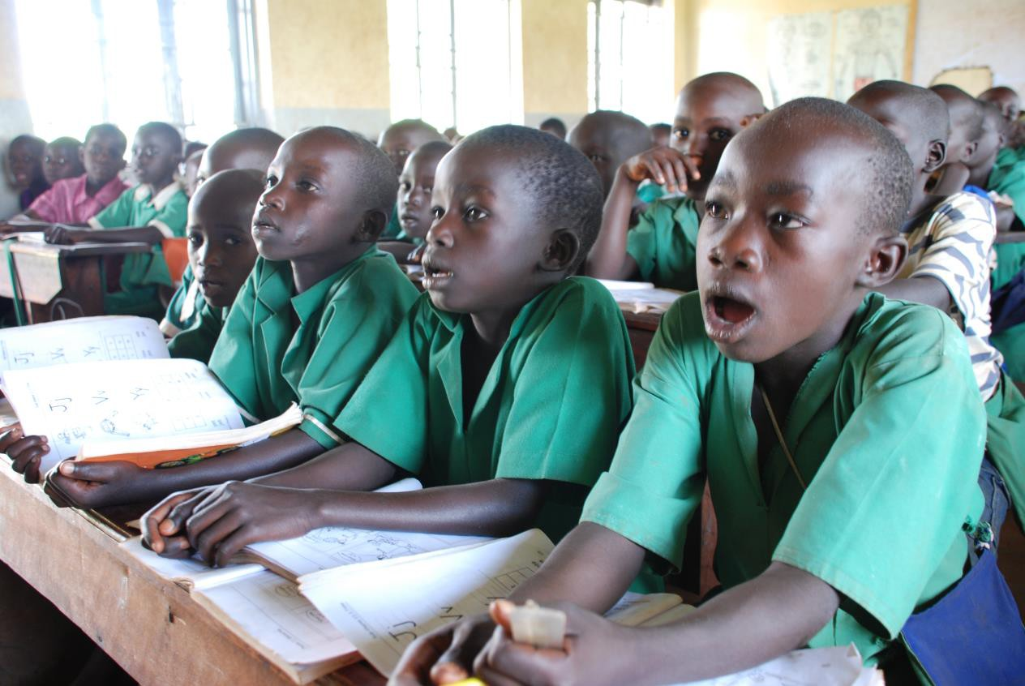
Empowerment, Equipping and advocating for improved Equity, Access and Quality of Education for Girls and Boys in the most vulnerable communities
in
2014

List of Acronyms
ADP | Area Development Program
AF | Agricultural facilitators
BEIP | Basic Education Improvement Plan
CCT | Centre coordinating Tutors
CLP | Community Literacy Project
CVA | Citizen Voice and Action
CWB | Child Well being
ECD | Early Childhood Development
EMIS | Education management Information System
ESSIP | Education Sector Strategic Investment plan
FENU | Forum for Education Non-Government Organizations in Uganda
GER | Gross Enrolment Ratio
LABE | Literacy and Adult basic Education
MOES | Ministry of education and Sports
NER | Net enrolment Ratio
PTA | Parents Teachers Association
RTI | Research Triangle Institute
SCALE | School community Accountability for literacy enhancement
SMC | School management committee
SMCA | School management committee association
STiR | School and teacher Innovations for Results
UNATU | Uganda National Association of teachers Unions
WVU | World Vision Uganda

Background
Education is the key to unlocking any child’s potential. World Vision seeks to provide education for life in order to help children live productive and fulfilling lives
World Vision’s education strategy seeks to assure that children attain the core skills and abilities they need to go on to lead a productive and fulfilling life. It aligns with the shared global commitment to the Education-for-All Dakar goal that calls for all children receiving, at a minimum, ‘recognized’ and ‘measurable’ levels of reading, basic mathematics, and the most essential life skills. At the same time, it aligns with the Ministry of Education and Sports Education Sector Strategic Investment Plan (ESSIP) 2005-2015.
In 2014, WVU focused on ensuring that children have equitable access to education through improving the physical, social cultural and phycho social environment for each child to access school, remain and complete school while at the same time achieving improved measurable learning outcomes in literacy, numeracy and life skills. In 2014 World Vision made significant progress increasing community engagement in education and made significant strides in supporting children in conflict to access basic education in the child friendly spaces. The capacity required to support implementation of World Vision’s Education program focuses on, but is not limited to, five core areas:
- Creating Strong Partnerships for Quality Education
- Capacity building of staff, partners, and teachers
- Community engagement
- Capacity building of community volunteers and parent support groups
- Abundant locally relevant and age appropriate learning and reading materials
World Vision has three frameworks or project models for its education program, one for early childhood ( Early Childhood Education (ECD)), one for primary education ( Basic Education Improvement Plans (BEIP)), and one for adolescents ( Positive Youth Development). Impact areas receive, at minimum, functional levels of reading, basic mathematics, and the most essential life skills
2014 Education in Numbers
- Expenditure on Education in Fy 2014 =$6.2million
- # of Education sponsorship projects in FY 2014 was 37
- # of non-sponsorship education project was 3
- # project schools = 550
- # of children in the project schools= 275,000
- # Classrooms constructed in 2014= 94
- # staff houses constructed in 2014=41
- # Latrine stances constructed in 2014 = 220
- # twin desks supplied to schools = 1317
- # of books purchased = 12900
- # of local material titles produced by communities using the shell book software=69 ( Pader (15), Oyam (23), Iyolwa (12), Kiboga(19))
- No of copies of locally produced materials printed and distributed to children= 38,000 (23,000 in Oyam, 5000 in Tororo and 10000 in Pader)
- # Teachers retooled in 2014= 1612 (male=1062, Female=550)
- # curriculum and subject master trainers trained = 126 (male=89, Female=37)
- #community literacy centres (reading clubs) established =40 (Aber (20) and Aboke (20))
- #community volunteers supporting out of school literacy activities =200
- # youth supported for vocational skills =814 (Males=367, Females=447)
- % of ADPs reporting improved literacy in 2014=78%
- % of ADPs reporting reduced drop out and improved completion in 2014 = 92%
- % of ADP reporting improved parents support to education activities through community led initiatives =100%
- % of ADPs reporting increase in the number of schools with functional school management committees=89%

Improving the learning environment for children through construction of infrastructure
One of the key program focus areas for WVU is to address the negative physical environment that that affect equitable access to education. In areas with poor school infrastructure communities have been supported to improve on the school infrastructure. In 2014 World Vision Uganda invested $2.9 million in construction of school infrastructure to provide a conducive learning environment for children. 94 classrooms, 21 twin staff houses and 220 stances of improved pit latrines were constructed in project areas. A total of 1317 twin desks were supplied to schools leading to improvement of the teacher desk ration in World Vision supported schools

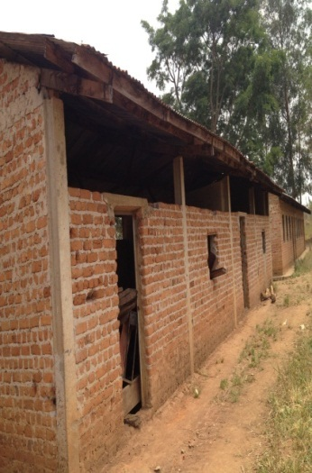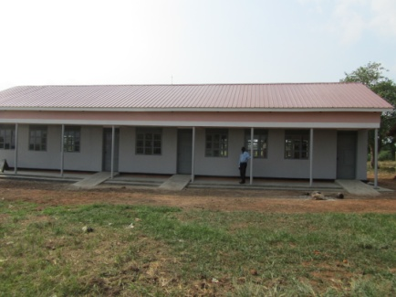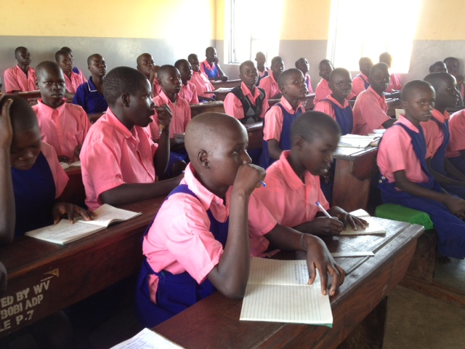
Above: Pupils of Abole P/S in Koro S/C attending class in the newly constructed block of 2 classrooms block with an office furnished with 3-seater classroom desks. On the left is the old and condemned classroom block that the pupils used to study in.

School Feeding initiatives supported by World Vision
The approach used is participatory method of learning where pupils and their teachers from different classes meet once in month with Agricultural Facilitators (AF) to build their capacity in food production. The best success story is in Buikwe District supported by WV Buikwe ADP.
WV Buikwe cluster facilitates the AF for conducting these sessions with support from the Sub-county. Monitoring is done by School Management Committee (SMC) with support from Ngogwe Sub-county Development Committee. Each class has its own food garden and they grow a specific food type though all food is shared by all pupils and teachers.
This approach responds more effectively to schools with a local resource such as land willingness of teachers to support children in their food gardens. This has not only promoted a culture of farming in schools but also has promoted consumption of nutritious foods for the learners, guaranteeing sustainable skills and knowledge acquired from the food gardens by the pupils and teachers. The best impact of this intervention can be seen in Namulesa SDA Primary where it was first implemented.
In 2012 the school had a total enrollment of 28 pupils. In 2014, the enrolment for Namulesa SDA Primary School increased to 314 pupils (172 boys and 142 girls) largely because of school feeding
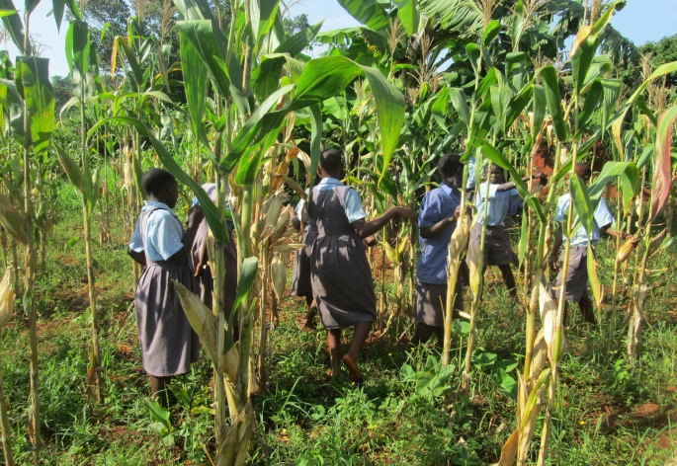  Namulesa P/S P7 class haversting maize from P.7 school garden | 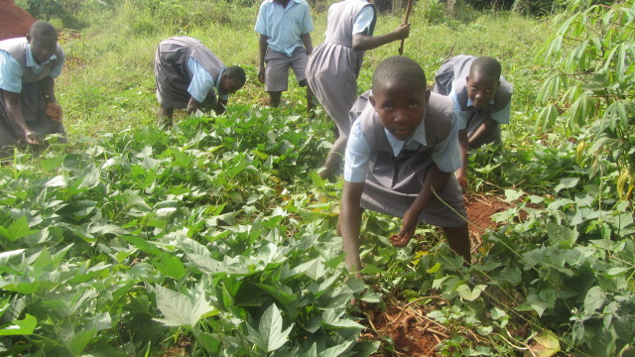  Namulesa P/S P.5 class weeding sweet potatoes
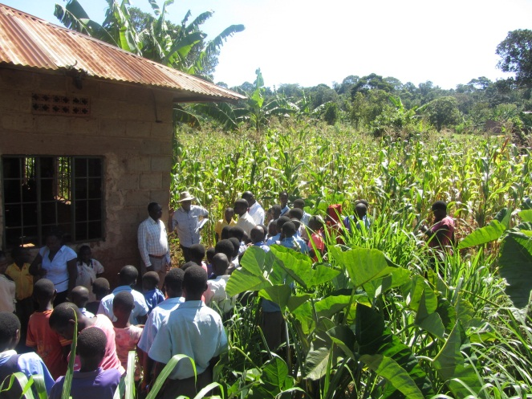  This is a view of a big garden of maize for Primary four class at Namulesa Primary School | 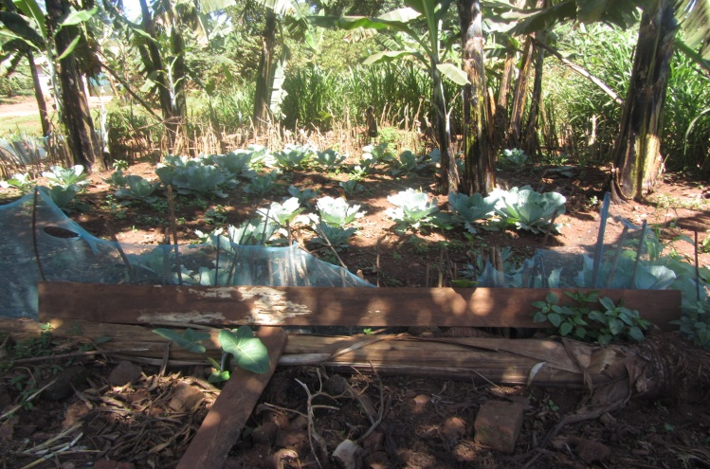  These are backyard garden of vegetables and Matooke for Primary three and Five

Kabanda Tonny 12 years, a pupil of Namulesa SDA Primary school narrates “……Each class has its own garden, children of different classes work together to make sure they take care of their gardens. Different classes would love to see that their gardens are outstanding as compared to those of other classes. We are glad that we are taking porridge, posho, beans, sweet potatoes and greens we plant in our school gardens. Some of us have food gardens at our home……”.
School teachers who play a big role in educating pupils about good feeding for mental and physical health share their excitement on the achievements made by the learners in addressing the problem of children learning without lunches. Mr. Okuta Charles, Head Teacher Namulesa SDA Primary School had this to say “…..I am always surprised when I look at the far the school children has been able to support Namulesa SDA Primary school. We grow our own food using the piece of land we have. We are glad that this approach is sustainable and it has a link with what we teach children in agriculture lessons and with what they practically do in their gardens
Making it possible for children to read and write
World vision recognises the importance of relevant reading materials for children in order to support reading. In 2014 World vision procured 12,900 books from Mk Publishers to support curriculum instruction. These books are used to support teaching and learning especially for children in P1-P3

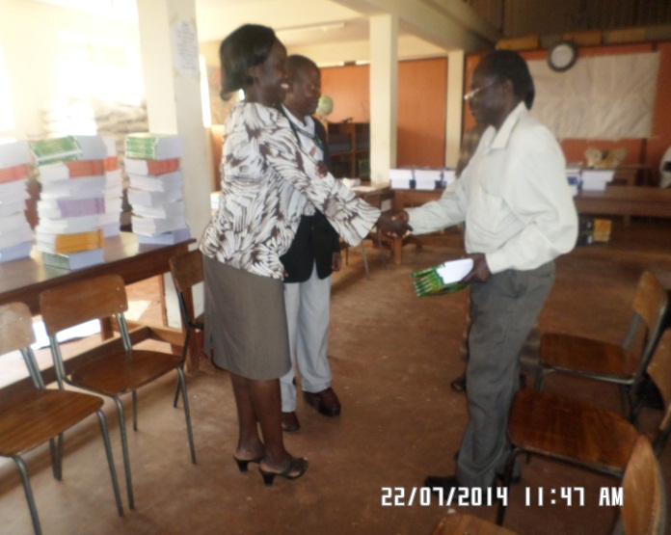
Programme manager, Ms Harriet Aloyo handing over textbooks to the District Education Officer Gulu
In all World Vision procured books worth over $120,000 from the publishers of books approved by the Ministry of Education and Sports. In addition to these World Vision has supplied books and education materials worth over $2 m to Primary schools, secondary schools and tertiary institutions. Ndejje University, Uganda Christian University, Uganda Marty’s University Nkozi, St Augustine International University are some of the beneficiary universities
Improving teachers’ accommodation
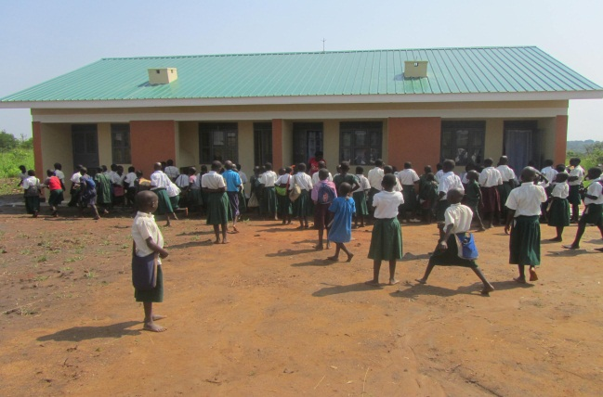
A typical twin house constructed by World vision such as one at at Panykworo P/S in Gulu
Celebrating reduced Drop out of children
The commitment to ensure that children who enroll in school should remain and complete basic education is high on WV agenda. In 2014 the number of communities celebrating reduced drop out children increased. All the ADPs that reported on dropout rate show an improved rate of retention for children. 9 out of 11 (81.8%) that reported on drop out are fall below the national average dropout rate 10.1%. World Vision has supported improvement of the physical learning environment through construction of school infrastructure and increased community engagement. Retention of the girl child has been enhanced by construction of good sanitation facilities in schools
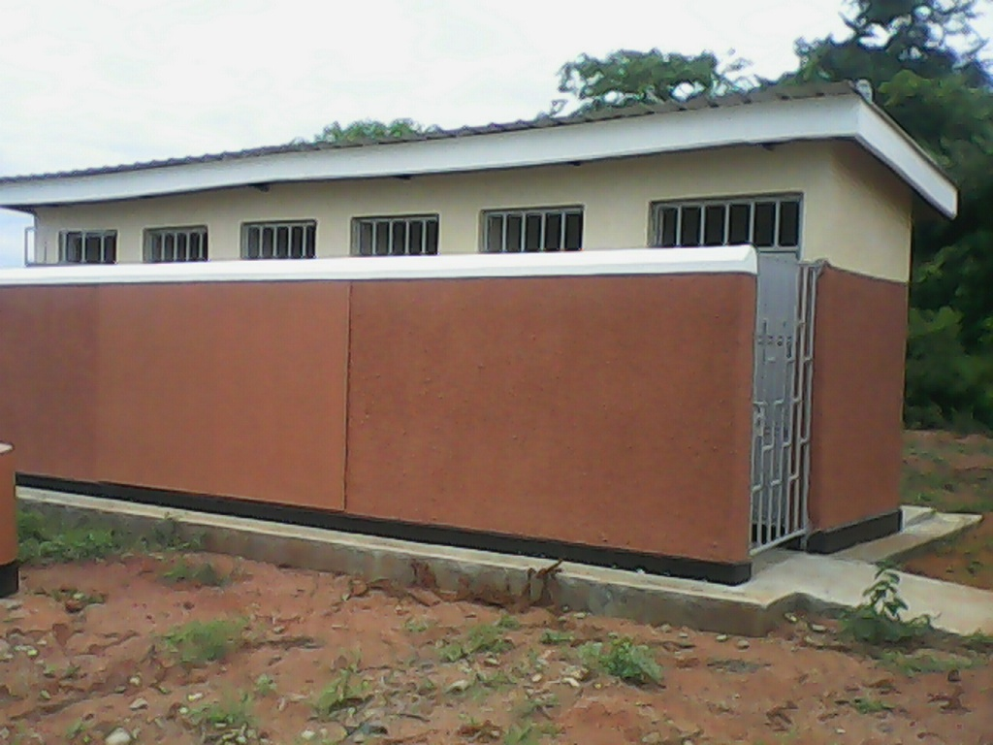
A 5 stance pit Latrine block in Busimbi Primary School in Namakoko parish Nankoma Sub-county.
This is a result of improved school classroom environment, better sanitation, and improved support for girl children, increased parents support for children and improved teaching and learning. The decline in Katwe, Kimu and Ntwetwe can be attributed to a strong local level advocacy and community engagement that has led to a sustainable school feeding program. In Aber the improvement is attributed to a vibrant and supportive School Management Committee Association that has improved school monitoring and parent’s involvement
Completion of basic Education
In 2014, 23 of 34 ADPs (68%)reported a progressive increase in the percentage increase of children completing basic education . 8 out of 11 (73%) ADPs that baselined this indicator in 2012 show an improvement in school completion rates in World Vision supported communities. 8 of 23 (35%) ADPs are well above the national average completion rate of 61%. The end girl child marriage campaign in Eastern Uganda was one of the major advocacy campaigns conducted by World Vision Uganda
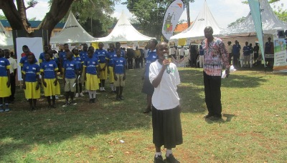
A school girl call upon addressing Stakeholders to protect children against child marriages during the “End Child Marriage Campaign in Tororo

This can be attributed to increased awareness and support by parents, improved support from local leadership, school feeding programs, better school infrastructure, improved support to the girl child through making of sanitary towels, functionality of children peer support groups and vigilance of school mangement committees and school inspectors.
Promoting access for the most vulnerable children
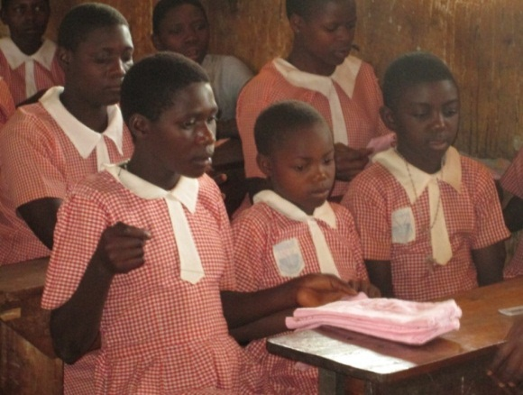
Promoting a safer primary learning environment and improved classroom and school management are expected to increase retention of the most vulnerable children One of the challenges has been in dealing with gender based violence especially on girls. World Vision has been deliberate on training children, parents and teachers in the primary causes of gender based violence in Busia, Nakasongola, and Pader. 560 Peer educators, 120 teachers and 500 parents have been trained. Key among the support to children is training them to manage their menstrual cycle by making sanitary pads. Senior women teachers and adolescent children are taught how to make pads and manage them
Girls making sanitary pads

WV has also been involved in supporting with special needs education to access education. Through the Gifts in Kind (GIK) 46 children received wheel chairs and clutches to support in their mobility. In addition WV has partnered with parents and local government to support enrolment of children with disability. In 2014 the enrolment for the Aber P/S disability unity rose from 161 in 2013 to 189 in 2014. Budumba and Kachonga area programs have also supported 38 children (21girls and 17 boys) to access primary education in Madera school of the blind and Ngora School of the deaf.
Literacy
World Vision inteventions in communities contributed to increased proportion of children that functionally literate at Primary six. 78% of Programmes reported an increase in the proportion of children in Primary six who can read with understanding as compared to 69 in 2013. 67% of ADPs reflect an average literacy rate that is well above the national average literacy rate of 40.1% in P6. This would not be a surprise because of the deliberate investment in community involvement in education, abundance of relevant reading materials, capacity development of teachers, functionality of school management committees and joint school monitoring by stakeholders.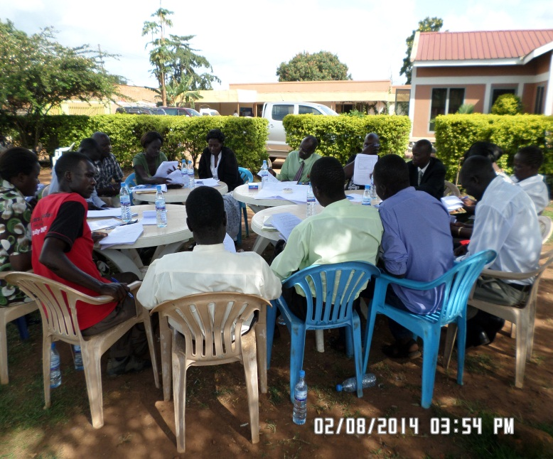
Teachers in a training sessions where they work together to support each other in preparing assessment materials
In 2014 there was an increase of teacher mentors as aresult of training of 129 curricum and subject master trainers in Pader, Busia, Rakai, Oyam, Kole and Kibaale. WV supported standardisation of assessment for upper primary by engaging district academic committees to have standardised test for upper primary.
Building partnerships for quality education
In 2014 World Vision hosted a summit of partners for quality education and the first educatio education summit for World Vision East Africa. The summit was attended by education leaders from World Vision E.Africa, the Global Centre, support offices , Officials from the Ministry of Education and Sport and local partners like RTI, British Council, Mango Tree, LABE, District Local government representatives and the media. This provided a strong foungation for building concrete relationships with partners through MoUs with Mango Tree, British Council, STiR education Uganda, Opportunity Education Foundation and Loro Core Primary Teachers college. World Vision supported and participated in education networks activities such as the Global Week of Action for education, the Day of the African Child, the bilingual network meetings and FENU support to UNATU.

School and community Accountability for Literacy Enhancement
World Vision has supported community ownership and support of literacy activities through the Community Literacy Project (CLP) that is implemented in Aber and Aboke in Oyam Kole Cluster. The community literacy project was initiated by the School management committee Associations (SMCA) of Aber and Aboke subcounties in Oyam and Kole districts respectively in a bid to close literacy gaps created by the long period of instability in the region. The project is designed to ignite parents’ and community invlvement to ensure that children develop their literacy skills. This is a capacity building and community empowerment project in which communities are organised around the school catchment area and create household clusters within which a reading cliub is established to support out of school and after school reading and play activities. The community also select among themselves a 5 volunteers to support these activities that are organised at least once a week. The volunteers receive basic training in supporting children and conduct parents’ awareness raising to support children. The School management committees ensure a strong link between these volunteers and the teachers and a strong support system evolves to ensure that children are protected and they develop literacy skills.
With support of World vision, the Cenre Coordinating Tutor and the School management committee Association, these volunteers work closely with parents and teachers to develop localised reading materials that are typed and produced at the local resource centre.
Through this project 24 ToTs (17 male and 9 Female) have been trained. Training guides and community engagement materials have been developed. Forty Literacy clubs have been established in the school catchment areas of Aber and Atura Primary schools of Abe Subcounty in Oyam district and, Achulibanya and Agwet Primary scholls in Aboke Subcounty in Kole District. 200 community volunteers (100 male and 100 female) were selected and have been trained. They are currently supprting literacy activities such as afetr school reading sessions for children, reading with children, peer support reading activities and parents awareness raising. Twenty five titles of leblango readuing materials have been developed, printed and are currently under use in communities.
The school management committee provides mentorship and a link with the schools. Through the literacy clubs parents and the parents engagement meetings, key issues affecting the school and their children are channelled to the School management committees which then engages the local governent authorities. This is the school and community accountability mechanism.
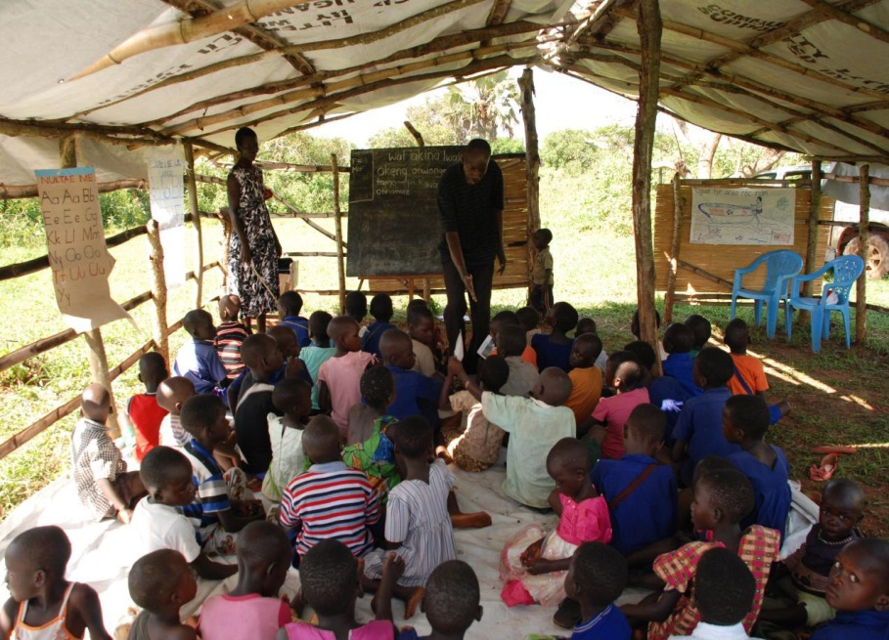
A typical community reading club with community volunteers assisting children to read.
At these community reading clubs parents are supported by World Vision staff and the Local language Board to develop local reading materials. The materials are illustrated by community and published using the shell book software developed by World vision. To support this local initiative, World vision supports training and the local Core PTC staff support grading of materials. World Vision has also worked with the District Education authorities rehabilitate two coordinating centre resource centres in Aber in Oyam district and Aboke in Kole District.
Above: Community volunteers are supported by the CCT to develop materials
This community initiative has seen the production of 43 titles in Oyam and Kole with more than 25,000 copies available for children in the reading clubs and in homes. Elsewhere 14 titles have been produced in Tororo, 10 in Pader, 19 in Kiboga, 10 in Arua and 14 in Rakai. These are very low cost local reading materials that build on community experiences and local stories. This intiative will be rolled out to all program areas.
Below: community volunteers developing learning materials for literacy improvement
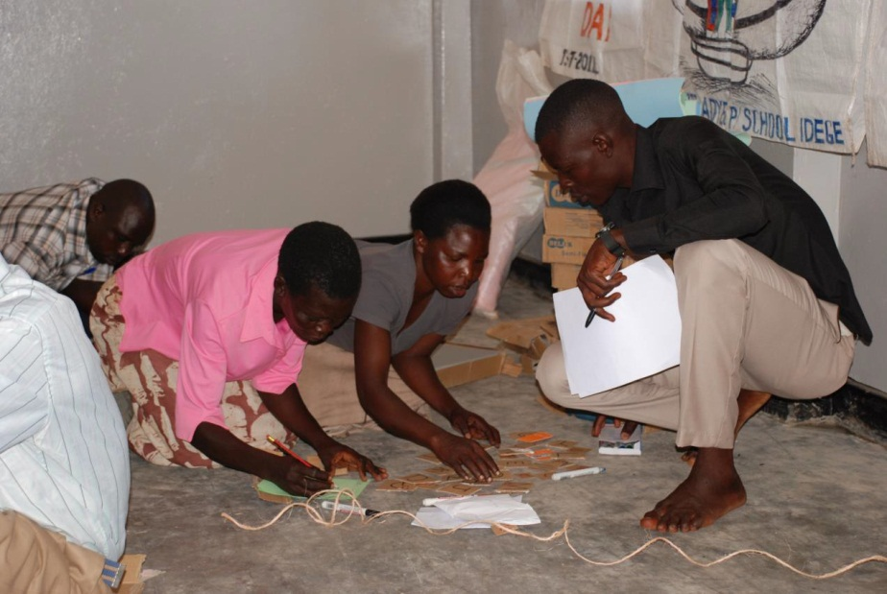
Through localization of reading materials the SMCs, teachers and community members have an opportunity to improve and appreciate their local language authography and its importance in teaching reading. Involvement of parents in development of reading materials also motivates them to support literacy activities such as reading with and for children, home reading buddies through peer support and provision of space and time for reading at home.
Parents also find time for storytelling and this supports development of morals and family values. In some case the grandmother becomes an invaluable teacher and an inspirer for the young children.
Key Learning’s in 2014 and Recommendations in education

Key Learning’s | Recommendations
Improvement in PLE performance is the greatest motivation for Parents and communities to support school activities | All projects should support all efforts to help children and teachers to conduct periodic assessment of learning and focussed revision in preparation for PLE
Integration of life skills development in the lives of school children at an early age will help them have positive attitude to education. Co-curricular activities have been found to be a pull factor for children enrolment and retention in school | Ensure total integration of life skills programming for all programs and projects  Support co-curricular activities in all schools
Reading materials produced by communities inspire them to support reading at home. | Roll out the community literacy project activities to all ADPs
Community literacy centers are a great opportunity for other education activities such as ECD and youth training activities | Support communities to develop a sustainable mechanism of developing reading resources for children
Joint involvement of partners in school monitoring increases community ownership and improves accountability by teachers and head teachers. | Increase parent’s participation in the Basic Education Improvement plan through PTAs  Support joint monitoring of schools
Timely availability of good data is a very powerful tool for advocacy. This is coming from the fact that previously there has been inconsistent aggregation of such data at national level to inform decisions on key indicators e.g. completion rates | Use the findings from this report to turn around poor school completion. All programs track this indicator on quarterly basis and inform national office for decision making. Deliberate efforts should be made to increase safety at school by reducing violence and abuse in school
High school enrolment at lower primary does not necessarily translate to same completion rates at high primary | Programs should engage local governments in addressing issues related to low completion rates at upper primary

