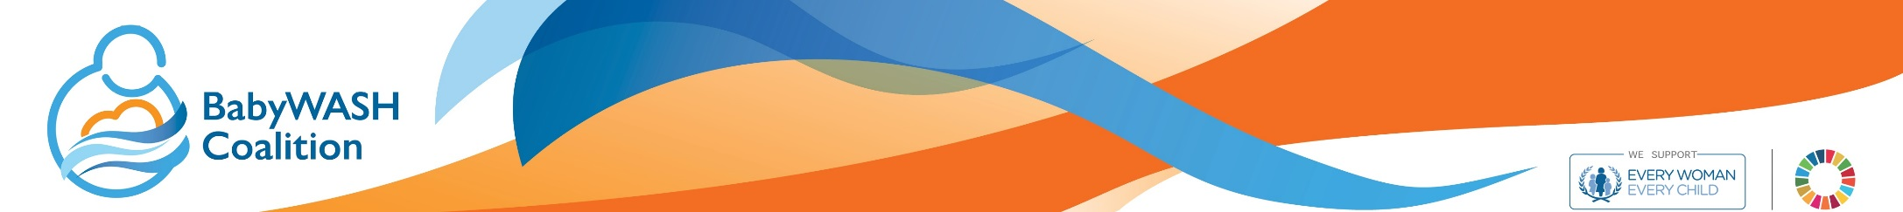

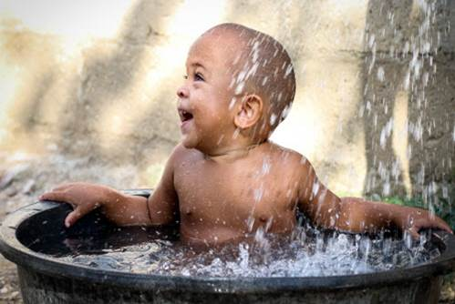

**Ensuring children survive and thrive through effective integrated action**

Briefing for decision-makers from the BabyWASH Coalition

info@babywashcoalition.org

**The challenge**

Over the past thirty years, we have witnessed remarkable improvements in the health of children worldwide. Millions more children are surviving and thriving thanks to investments that prioritized access to health care. However, the job is not complete. The challenges that we face today are multifaceted and will only be overcome with the collaboration of diverse experts and institutions. Some of the most pressing problems we face today are:

* 159 million children under five are stunted, their cognitive and physical development damaged irreversibly by chronic malnutrition[1], and 50 million children under five are wastedii, their risk of death from childhood diseases such as pneumonia and diarrhea 2.3 times higher than their non-wasted peers[2].
* One in ten (663 million people) do not have access to safe water[3], and one in three (2.4 billion people) do not have access to a proper toilet[4].
* Around 315,000 children under-five die every year from diarrhoeal diseases caused by unsafe water and poor sanitation[5]. That's almost 900 children per day.
* 43% of all children under-five in low- and middle-income countries are at risk of failing to reach their developmental potential due to poverty and stunting[6].

Child development in the early years of life has a myriad of contributing factors that all need to be addressed to make substantial progress towards the Sustainable Development Goals (SDGs). Sector-specific, siloed approaches will not have the impact we want to see in this new SDG era. Therefore, innovative multi-sectoral approaches are urgently needed, for both efficiency and effectiveness, as we collectively seek to achieve health and prosperity for all by 2030.

**The case for a more integrated approach**

1. **The first 1,000 days are a crucial window for children to thrive.**
2. **Solutions must cross sectors to have the largest impact.**
3. **Integrated investments yield strong returns, economic growth, and sustainability.**

1. **The first 1,000 days are a crucial window for children to thrive**

From conception to two years old – the first 1,000 days – a child’s brain is developing more rapidly than it ever will again. Poor conditions in those early days, including lack of access to health care, lack of clean water and sanitation, malnutrition, and neglect can cause developmental and cognitive delays that are never fully overcome, even later in life.

|  |
| --- |
| *“Around 50 percent of the gains in the health of women, children and adolescents result from investments outside of the health sector. These include interventions and policies in education, nutrition, water, sanitation and hygiene, social protection and poverty reduction, child protection, labour, transport and energy.”*  - The Global Strategy for Women’s, Children’s and Adolescent’s Health (2016-20) |

***Children’s early development requires nurturing care [7]- defined as health, nutrition, security and safety, responsive caregiving, and early learning - provided by parent and family interactions, and supported by an environment that enables these interactionsvii.***

* Adequate, balanced nutrition in the first 1,000 days, including exclusive breastfeeding for 6 months, followed by complimentary feeding until age 2, sets the foundation for cognitive growth and development, and reduces the likelihood of stunting and infection, leading to better school performance, improved lifelong health and higher wage earnings.
* Improved access to high quality clean water, sanitation and hygiene [8](WASH) during pregnancy and childbirth can reduce maternal and newborn mortality and morbidity by decreasing rates of infection, including sepsis. Healthy WASH conditions and behaviours in a young child’s feeding and play areas can prevent diarrhoea, infections and likely reduce environmental enteric dysfunction (EED), which can otherwise cause chronic undernutrition.
* Nurturing care during a child’s early days promote feelings of security and attachment, and stimulates the brain to create new pathways, setting the child on a proper developmental trajectory.

**2. Solutions must cross sectors to have the largest impact.**

The challenges faced by the world’s poorest and most vulnerable communities are multi-sectoral; traditional solutions are no longer adequate to sustain gains. As global and national data improve, it is becoming clearer that the poorest families and communities are most likely to be left behind by traditional approaches, and that interventions must be linked together more closely to adequately address the needs of the poorest.

Furthermore, the SDGs are inseparable. Since undernutrition is linked to poor WASH through the diarrhea pathway, SDG 2 (end malnutrition) cannot be achieved without universal access to adequate water, sanitation and hygiene (SDG 6). Similarly, Universal Health Coverage (under SDG 3) and quality education for all (SDG 4) will be impossible without clean water, toilets and good hygiene in all health care facilities and schools. **Therefore, ministries, political leaders and policy-makers need to break down siloes to address challenges in new, more integrated ways that focus on outcomes rather than outputs**.

* The Health and WASH sectors must work together to reduce infection in hospitals due to lack of hygiene and sanitation[9] that can lead to maternal and neonatal death[10].
* The WASH and Education sectors must work together to ensure that children can attend hygienic schools to increase attendance rates and learning[11], and to address the needs of children of pre-school age.
* Nutrition, WASH and early childhood development experts must work together to ensure that young children get proper nutrition and stimulation in a clean environment that promotes heathy growth[12].

|  |
| --- |
| *“Education is interlinked with other sectors, just as health, nutrition, water and energy sources are central to education. Children’s health determines their ability to learn, health infrastructure can be used to deliver education, and healthy teachers are indispensable to education sector functioning.”*    – Global Education Monitoring Report 2016 |

**3. Integrated investments yield strong returns, economic growth, and sustainability.**

As national and sub-national governments, donor agencies, and the private sector aim to increase their returns on investment in health, education, and WASH, more coordinated and integrated approaches that deliver multiple interventions within one package are the best investment. With a multi-sectoral focus, it is easier to turn our attention to ensuring that children in all LMICs survive and thrive. Therefore, governments should align their work to global strategies that incorporate multiple sectors. Some examples for the strong economic advantages of integrated approaches are:

* The Global Strategy estimates at least $100 billion in demographic dividends from investments in early childhood and adolescent health and development[13].
* For every £1 invested in water and sanitation an average of at least £4 is returned in increased productivity, primarily based on improved health and more time at work[14].
* Evidence from both developed and developing countries suggests that an additional dollar invested in high quality preschool programmes will yield a return between US $6 and US $17[15].

|  |
| --- |
| *“Direct undernutrition interventions, even when scaled up to 90 percent coverage rates, have been estimated to address only 20 percent of the stunting burden. Tackling the underlying drivers of nutrition, particularly in [agriculture; health; education; social protection; and water, sanitation, and hygiene], is key to addressing the other 80 percent….Preventing malnutrition delivers $16 in returns on investment for every $1 spent.”*  - Global Nutrition Report 2016 |

**How to integrate effectively**

While there is no ‘one size fits all’ method, entry points for shifting mindsets, processes and programmes towards more effective integration can be to:

* **Improve sharing of information and data** between sectors and government ministries responsible for health, nutrition, WASH and education services. This can inform a context analysis of a country, and highlight the overlaps that exist between multiple concerns such as high rates of undernutrition and low WASH access.
* **Leverage existing working groups and coalitions to establish cross-government coordination mechanisms** for policy development, planning and budgeting on health, nutrition, WASH and education.
* **Coordinate interventions within the same geographical area and target population**. For example, a WASH programme will be more ‘nutrition-sensitive’ if it targets mothers and children already taking part in nutrition programming with improved water and sanitation infrastructure and good hygiene promotion (including food hygiene).
* **Build the capacity and knowledge of frontline health workers, teachers and caretakers** in the intersections between health, nutrition, education and WASH. For instance, strengthening community health worker outreach programmes, or ensuring that those delivering routine vaccinations also promote good hygiene behaviours.
* **Build NGO and government staff capacity in the measurement of early child development and early child education outcomes** (e.g., using IDELA, MELQO) to use alongside of traditional measurement tools for health, nutrition and WASH interventions.
* **Research the long-term impacts of integrated interventions, documenting and sharing programmatic learning** in order to continually strengthen the evidence base and rationale for integration.

**Action is needed by all actors if we are to deliver the necessary changes for effective integration to improve child health and well-being and decrease child and maternal deaths.**

**BabyWASH Integrated Action**

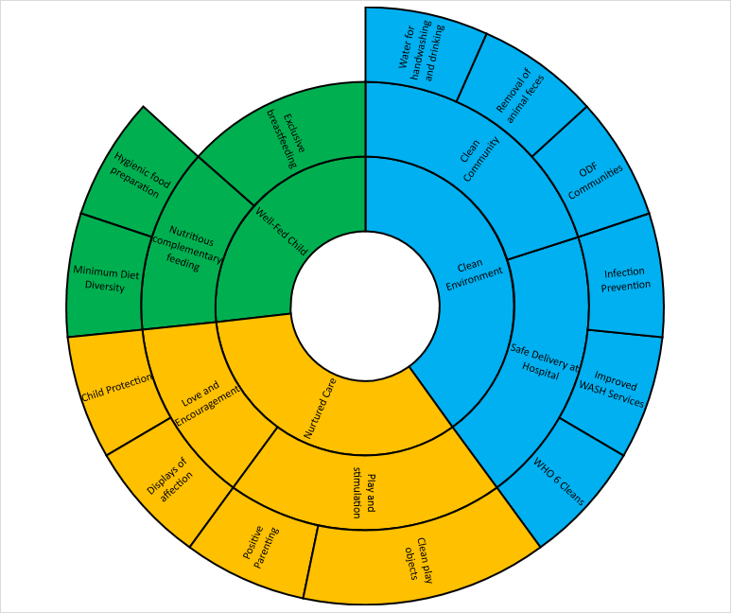

Figure 1: The above diagram illustrates how multi-sectoral interventions build on each other (beginning with the outer circle and moving towards the middle), resulting in a thriving, healthy child. WASH/health (Blue), early childhood development (Yellow) and nutrition (Green) are all essential to ensuring that children thrive in the early years.

Thriving Child

**Messages for Key Audiences**

National governments should:

* Engage communities in assessing needs and priorities, and in designing, implementing and evaluating integrated approaches.
* Ensure political support at the highest levels for integrated responses to multi-faceted health problems through national and sub-national policy and budget prioritization.
* Create and provide long-term support to high level steering committees that involve multiple ministries to share data and develop joint strategies and workplans.
* Develop multi-year plans to finance integrated programmes and ensure sustainability that are costed and commit ministries to integrated objectives.
* Assess long-term impact of integrated programmes through the inclusion of cross-sectoral indicators in monitoring and evaluation frameworks.
* Ensure that staff from all relevant ministries understands how their work can contribute to improved health and nutrition outcomes by providing intervention lists, etc.
* Ensure integrated programmes are included in Global Financing Facility Country Investment Case frameworks as well as other funding mechanisms.

Donor agencies should:

* Provide more flexible, long term funding to partner countries in support of integrated priorities, and for learning and adaptation as part of multi-sectoral approaches.
* Incentivize, encourage and facilitate cross-government coordination, ensuring that all relevant ministries are represented in planning, financing, implementing and evaluating programmes.
* Improve the tracking of cross-sectoral investments to better understand return on investment and enable stronger accountability (for example, improve the coding of ‘nutrition-sensitive’ ODA spending in OECD DAC reporting).
* Fund research to add to the evidence base for the effectiveness of an integrated approach.

Multilateral institutions and UN agencies should:

* Build on early efforts to strengthen coordination between sector-specific multilateral institutions focused on health, education, nutrition and WASH, such as the partnership between the Scaling Up Nutrition (SUN) Movement and the Sanitation and Water for All (SWA) Partnership.
* Provide resources in a more integrated fashion to country governments and implementing organizations.
* Be champions of support at the local level for integrated approaches and innovations, and disseminate successful models.

Civil society organisations should:

* Support, finance and document programmes that can inform national policy-making and planning processes with lessons learned from integrated approaches.
* Ensure community representation during government policy and budget making processes to ensure concerns of affected communities are addressed when prioritizing integrated approaches.
* Collaborate with each other and with academics to strengthen the evidence base for effective integration, and seek to share lessons and good practice.
* Hold leaders accountable for upholding their commitments to holistic health of children and societies through championing integrated approaches.

Private sector organisations should:

* Work closely with governments to support and facilitate cross-sectoral initiatives to improve child health, nutrition and access to education and WASH services.
* Finance pilot programmes or research studies to strengthen the evidence base for what works in effective integration.
* Embed integrated approaches and messages within product and service marketing strategies relevant to child health (for instance, help to promote proper food and hand hygiene through the sale of cleaning and sanitation products).

Academic institutions should:

* Assist in the creation of key indicators to measure the economic and health benefits of integration.
* Partner with NGOs and governments to generate more data on the effects of integrated programming, especially those integrating 3 or more sectors, by conducting impact assessments.
* Break down department research siloes to more easily engage in multi-sectoral research.
* Disseminate evidence to policy makers to ensure data leads to change.

Community members should:

* Advocate for their health needs and make clear the interconnected linkages between health outcomes.
* Talk with leaders in the community about a holistic view of health for women and children.

**About the BabyWASH Coalition**

The BabyWASH Coalition is a group of organisations focused on increasing integration between water, sanitation and hygiene (WASH), early childhood development (ECD), nutrition, and maternal, newborn and child health (MNCH) programming, policy-making and funding to improve child well-being in the crucial first 1,000 days of a child’s life; from conception to age two.

**Website** [**http://babywashcoalition.org**](http://babywashcoalition.org/)

**Email** [info@babywashcoalition.org](mailto:info@babywashcoalition.org)

**Appendix 1 – Case Studies of Integration**

**Case Study 2**

On the remote island of Tanna in Vanuatu, World Vision implemented a coordinated WASH and MNCHN programme with specific focus on mothers and children under 5. This unprecedented health education programme began with an existing WASH project and added a MNCH project, with goals to reduce disease among children under 5 and improve nutrition practices of women and children, antenatal care, postnatal care, hygiene and sanitation practices, and access to health services.

***Increased community ownership and engagement of the integrated WASH and MNCH*** programme allowed for additional beneficiaries to be reached more rapidly. Because the project featured a cross-learning approach of WASH, health, and nutrition, it was not labeled as “only for women and children”. This set the foundation for community involvement, community pride, and allowed men to feel involved in the process and planning. Overall, 20 communities were trained in hygiene, sanitation, and nutrition, exceeding the target of 10 communities. The impact of this integrated programme exceeded that of previous “WASH only” projects, and has thus far proven more sustainable, as significant changes in nutritional practices and reductions in disease prevalence have been observed.

**Case Study 1**

Nutrition at the Centre (N@C) is an innovative CARE programme focused on improving nutritional outcomes for mothers and children through integrated approaches of MIYCN, WASH, food security, and women’s empowerment. Specifically, N@C aims to reduce anemia in women (age 15-49 years) and stunting and anemia in children (age 0-24 months) in Bangladesh, Benin, Ethiopia, and Zambia.

The integrated approach between nutrition and WASH can be seen within the N@C Nutrition Support Groups or Village Savings and Loans Associations, where BabyWASH messages are disseminated. Key points include handwashing at critical times, separating children and animals, proper sanitation to reduce exposure of children to animal feces, and education on how to maintain a clean home. N@C also integrates nutrition and WASH curriculum into finance education, provides education on the link between poor hygiene practices and nutritional outcomes, and incorporates modules on BabyWASH practices into nutrition programming.

***Various partnerships have formed across the sectors to carry out this programme***. In Zambia, environmental health technologists collaborate with health workers to distribute the BabyWASH modules. In Benin, a Learning Practice Alliance is being conducted with the mayor’s office, Ministry of Health, Ministry of Agriculture, Ministry for Family Services, NGOs, and community leaders. The collaboration of these stakeholders will hopefully lead to more sustained integration in the future.

**Case Study 3**

In 2012, GOAL began implementing Nutrition Impact and Positive Practice (NIPP) circles in South Sudan, Sudan, Niger, Malawi, and Zimbabwe. NIPP consists of male and female community members who gather on a regular basis to discuss ways to improve nutrition security and care practices of households affected by or vulnerable to malnutrition. NIPP sessions focus on the link between multi-sectoral issues and poor health and nutrition and discuss ways to practice locally available solutions.

Since 2013, NIPP has impacted more than 19,000 beneficiaries in five countries. The success of this cross-learning programme is in part due ***to implementation by a multidisciplinary team. All members are trained on every aspect of the integrated approach, and provide support during all parts of the programme.*** For example, a nutritionist is trained on WASH and micro-gardening, and a WASH expert is trained in nutrition and health.

Data shows that NIPP is having a positive impact on behaviour change, as programme attendees demonstrated increased knowledge related to health (86%) and nutrition (>91%). A significant increase in NIPP participants who provide a minimally acceptable diet (MAD) for their families increased from 19% at baseline to 59% by graduation. NIPP has also been successful in treating MAM, with an 82% cure rate among children 6-59 months. Among PLW with MAM who were admitted to the NIPP programme, 75% were non-MAM at graduation. Diarrheal disease in children also decreased by 47% by the end of the programme as compared to the baseline.

1. Global Nutrition Report (2016) *From Promise to Impact: Ending malnutrition by 2030.*<http://ebrary.ifpri.org/utils/getfile/collection/p15738coll2/id/130354/filename/130565.pdf>
2. McDonald (2013) *The effect of multiple anthropometric deficits on child mortality: meta-analysis of individual data in 10 prospective studies from developing countries.* The American Journal of Clinical Nutrition.<http://ajcn.nutrition.org/content/97/4/896.full>
3. WHO/UNICEF Joint Monitoring Programme for Water Supply and Sanitation (2015) *Progress on Sanitation and Drinking Water: 2015 update and MDG assessment.*<https://www.wssinfo.org/fileadmin/user_upload/resources/JMP-Update-report-2015_English.pdf>
4. Ibid.
5. Explanation of this figure is provided on WASHWatch.org. WASHWatch (2015) *Why has the number of children dying from diarrhoeal disease due to poor WASH significantly dropped?*<http://washwatch.org/en/blog/why-has-number-children-dying-diarrhoeal-disease-due-poor-wash-s/>
6. Black (2016) *Early Childhood Development Coming of Age: Science through the life course*. The Lancet.<http://www.thelancet.com/journals/lancet/article/PIIS0140-6736(16)31389-7/fulltext>
7. WHO and UNICEF, supported by The Partnership for Maternal, Newborn & Child Health (PMNCH), the ECD Action Network (ECDAN) and many other partners (including the BabyWASH Coalition), are leading a process to scale up action and results for early child development in collaboration with countries and all other relevant stakeholders. This process will result in a Nurturing Care Framework to guide policy, programme and budget support.
8. The recently released SHINE and WASH Benefits trials suggest that our current level of WASH interventions is not enough to see impact on stunting. It is likely that a higher level of environmental sanitation and cleanliness is needed to see impact, and therefore WASH interventions must be of the highest quality possible.
9. WHO & UNICEF (2015) *Water, sanitation and hygiene in health care facilities: Status in low- and middle-income countries and way forward*.<http://www.who.int/water_sanitation_health/publications/wash-health-care-facilities/en/>
10. ‘Global, regional and national causes of child mortality in 2000-13 with projections to inform post-2015 priorities: an updated systematic analysis’, Lancet 2014<http://dx.doi.org/10.1016/S0140-6736(14)61698-6>
11. UNESCO Global Education Monitoring Report (2016) *Education for People and Planet: creating sustainable futures for all.*<http://unesdoc.unesco.org/images/0024/002457/245752e.pdf>
12. World Health Organization (2008c) *Safer water, better health: Costs, benefits and sustainability of interventions to protect and promote health*.<http://whqlibdoc.who.int/publications/2008/9789241596435_eng.pdf>
13. Ibid.
14. Hutton (2012) *Global costs and benefits of drinking-water supply and sanitation interventions to reach the MDG target and universal coverage*, World Health Organization: [www.who.int/water_sanitation_health/publications/2012/globalcosts.pdf](http://www.who.int/water_sanitation_health/publications/2012/globalcosts.pdf)
15. World Bank. Early Childhood Development Overview. Accessed 22 March 2017.<http://www.worldbank.org/en/topic/earlychildhooddevelopment/overview>