BabyWASH Coalition Launch Communications Toolkit
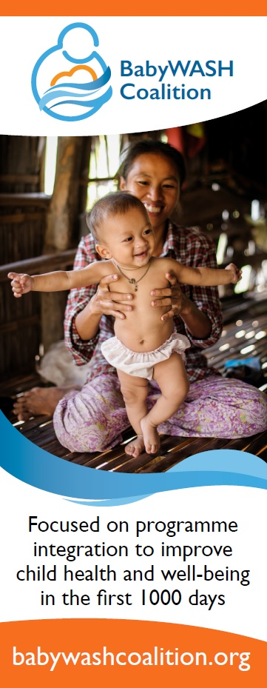
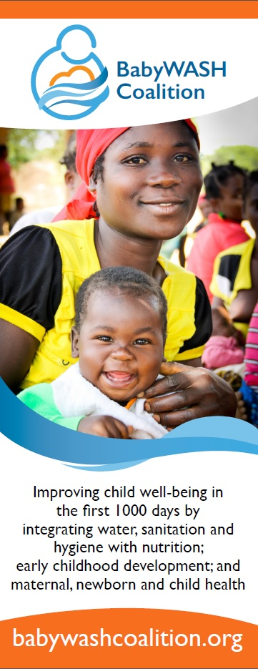

September 2016

The BabyWASH Coalition
The official launch of the BabyWASH Coalition is slated to take place at a high level Every Woman Every Child reception on the night of Tuesday September 20th. There is not room for many of us in the room to support, so Coalition partners are taking to social media to create excitement for the launch. This toolkit is meant to resource partners to make social media engagement as easy as possible. Our main goals around the communications of the launch are for:
- More organizations to hear about the work of the Coalition and know how they can get involved, including private sector partners and funders
  - Involvement can look like signing up for the newsletter, getting involved in the SuSanA thematic discussion we are hosting in October, or getting involved in the work of one of the workstreams
- The Coalition is seen as a flagship multi-stakeholder initiative in support of the SDGs
  - Getting a spot at the high level EWEC event will go a long way in this, but we also need to continue to target communications at organizations so they know about us.
Please be thinking about which organizations you think are essential to have working in the Coalition and how you/us can target them in the coming weeks. If you have any suggestions, please e-mail Peter Hynes (peter_hynes@wvi.org). He will be reaching out to some of you individually as well to see which organizations you may be able to be in charge of outreach to.

Times to be active on Social Media
The entire week of UNGA (and beyond) is a good time to be promoting the Coalition. A good rule of thumb would be one tweet or comment per day. If we could get that from all 30+ officially confirmed organizations, we could have a strong social media presence all week. There are three times that we want you to specifically focus on sending out messages:
1) Tuesday Evening September 20th 6-8:30pm: High Level EWEC Reception
During the High Level Reception, the BabyWASH Coalition will have a time to launch. Kevin Jenkins, CEO of World Vision International, and Sarina Prabasi, CEO of WaterAid America, will be giving the announcement. It would be great if all partners could send out the press release earlier in the day on the 20th and then send a tweet in support of the launch during the reception (see sample tweets below)
2) Thursday September 22nd – All day Social Media Relay for EWEC – BabyWASH Coalition assigned to 10:45am – 11:30am EST specifically
This year, Every Woman Every child is doing a social media relay each day of UNGA. The BabyWASH Coalition is signed up to help on Thursday when the theme is “Transform: cross-sectoral work and partnerships.” Specifically, we have a 45 minute time slot to focus our social media engagement. It would be great to send out tweets supporting SDG17 and the need for partnerships to make progress on the SDGs, with #EWECisME in each tweet.
3) September 26th – 28th – Reminder to get involved with the Coalition
There is a lot happening at UNGA. So we specifically want to focus some tweets after the UNGA events have ended. In the three days after UNGA, we want to target specific organizations and invite them to sign up for the BabyWASH newsletter, e-mail the coordinator to get more involved, and mark their calendars for the SuSanA discussion happening in October. A reminder will be sent first thing Monday September 26th to remind you about these important tweets.

Hashtags
Main
The main BabyWASH hashtags are meant to link all of our communications together:
- #BabyWASH: This hashtag is recommended for all tweets. We have not used social media much up to this point so we want to start using this hashtag to identify it with our Coalition more strongly
- #EWECisME: Any tweets in support of EWEC and anything posted on Thursday should include this hashtag

Additional
These Hashtags can be used to link your content to the larger conversation around UNGA and the sustainable development goals depending on the content of the tweet. Feel free to use others
- #UNGA
- #globalgoals
- #SDGs
- #IntegratedDev
- #WASH
- #nutrition
- #ECD
- #MNCH

Press Release
We have drafted a press release for the launch of the Coalition. We would ask each organization involved in the Coalition to publish the press release on Tuesday (Sept 20th) in preparation for the launch on their website, and then link to it through tweets. Full text is in the Annex of this toolkit – feel free to edit slightly and make sure to put your organization name at the beginning. We want the main messages to be the same, hence the unified press release. If you want to link to the press release, the link is: http://bit.ly/2c8hbts (the link won’t be live until Tuesday, and it has World Vision in the first line, so you’ll have to say something like “Excited to join World Vision” if you want to link)

Blogs
The Coalition has written three blogs in the lead up to the launch, each one based around one of the three workstreams. Please re-post and direct people to these blogs via your social media channels.
1) CARE Blog on Integration metrics:
https://care-nutritionatthecenter.com/2016/09/12/the-babywash-coalition-care/
Short Link: http://bit.ly/2cSY8Jn
2) World Vision Blog on Programme Guidance:
http://wvi.org/clean-water-sanitation-and-hygiene-wash/blogpost/better-recipe-child-health-and-nutrition
Short Link: http://bit.ly/2cUGKzX
3) WaterAid Blog on Advocacy:
http://www.wateraid.org/news/blogs/2016/september/breaking-down-siloes-with-the-babywash-coalition
http://bit.ly/2cjQln1

Sample Tweets
General
Save 420,000 babies, 31,000 women each year! Integrate WASH, ECD & MNCH progs, policy, funding. babywashcoalition.org

Heard about the new BabyWASH coalition launching during #UNGA? Learn more here http://bit.ly/2c5espa

@JimYongKim: “scaling up investments in nutrition and other types of early childhood development services will help end stunting” #BabyWASH
Video from #DefeatDD showing the many sectors involved in improving child well-being http://bit.ly/1pKcAEI #BabyWASH
Tackling diseases that affect children takes investment from all sectors! Infographic from #DefeatDD http://bit.ly/2cpTLBZ #BabyWASH
Malnutrition, diarrhoea, edu all overlap in first 1,000 days. Infographic from #DefeatDD http://bit.ly/2c6VOIO #BabyWASH #IntegratedDev

Tweets Linking to Blog Posts (Friday 16 September and on)
How can we measure an integrated program? Check out this great blog by @CARE for some thoughts http://bit.ly/2cSY8Jn #BabyWASH
Why should we include multiple sectors in our programming? Comment on @HealthWV #BabyWASH blog http://bit.ly/2cUGKzX
“Poverty will not be ended through siloes” says @danrodmanjones from @wateraid in new #BabyWASH blog http://bit.ly/2cjQln1

Tweets for Press Release (Tuesday 20 September)
NGOs, academia, pvt sector, UN agencies, govts, join us to save half a million children a year [link to news release] #BabyWASH #SDG17

NEWS: New global coalition aims to save half a million babies a year from preventable deaths [link to news release] #BabyWASH

Excited to join World Vision and over 30 other orgs in the launch of the #BabyWASH Coalition! http://bit.ly/2c8hbts #SDG17

Tweets for EWEC Social Media Relay (Thursday 22 September)

#BabyWASH Coalition to focus on the interconnectedness of the #globalgoals at the start of life #EWECisME #UNGA

Tweets to Invite Orgs to Participate
#UNSG: “we must work together, across sectors and industries, in broader and deeper partnerships” Join us! http://bit.ly/2cpoUX5 #BabyWASH
Hey, [Twitter handle of target orgs] would love your help to save 420k children and 31k women a year from preventable deaths. #BabyWASH
Stay involved with #BabyWASH through our hosted online discussion in October. Details: http://bit.ly/2cuggax
Stay current with #BabyWASH Coalition news and products through our newsletter! http://bit.ly/2cGIsWn

Sample Images to Use
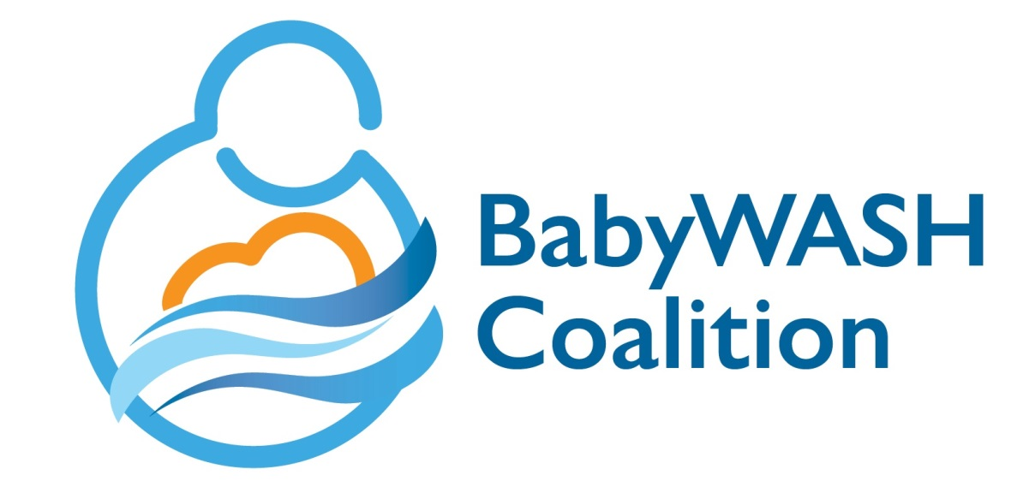
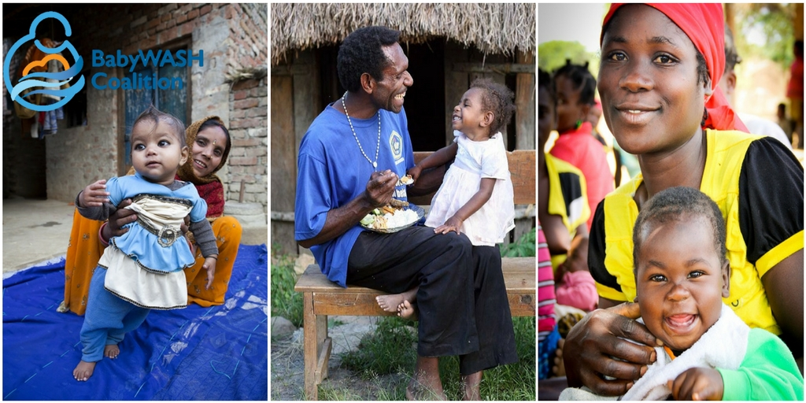
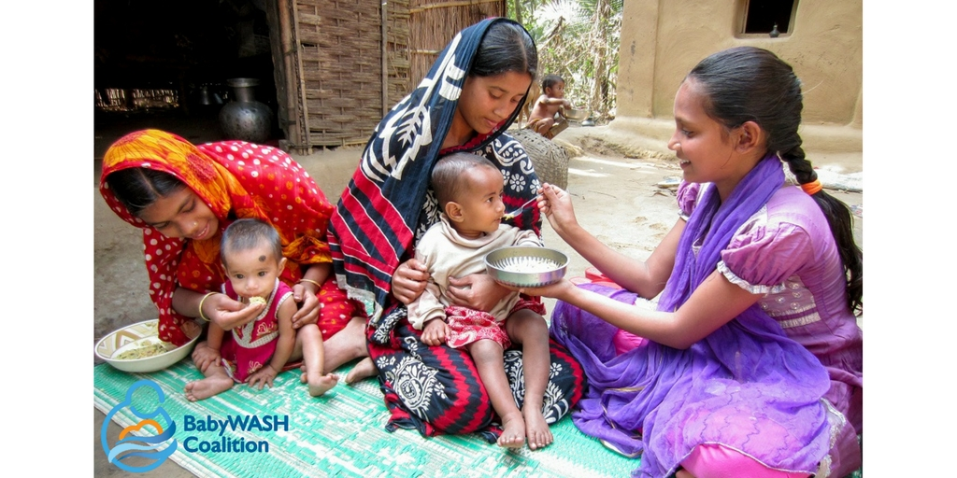
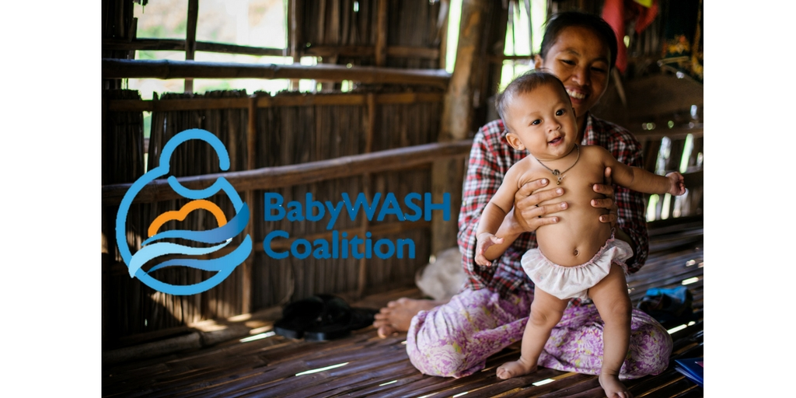
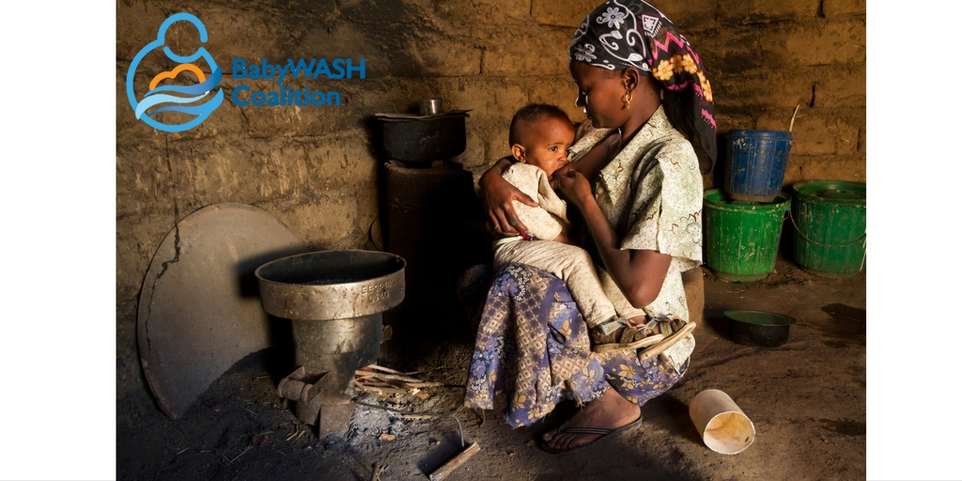
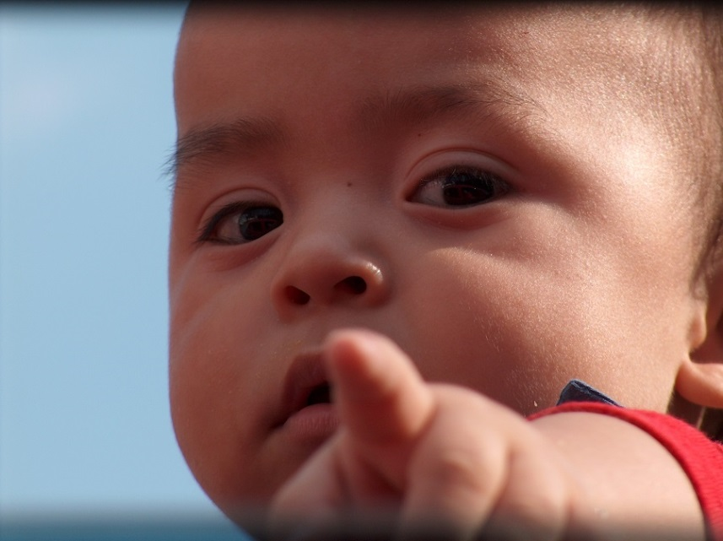
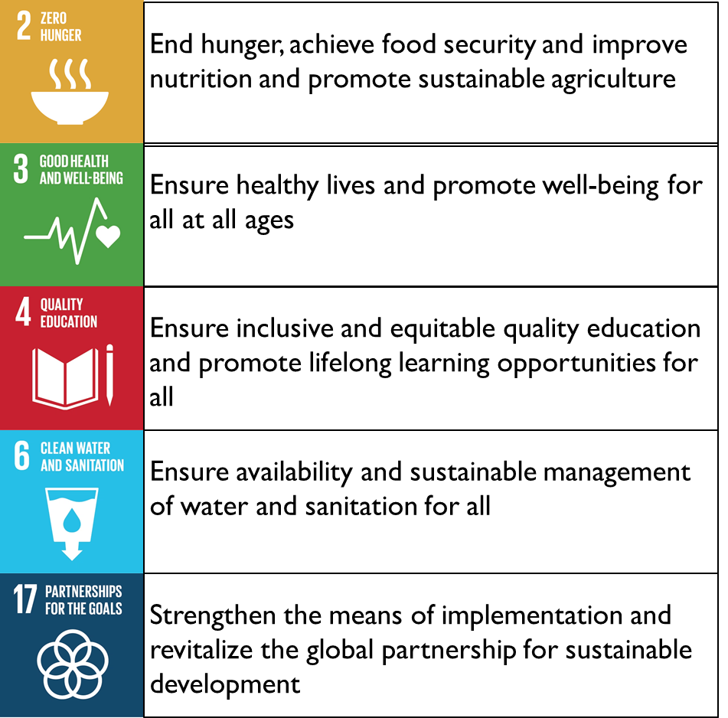

ANNEX – Press Release for Launch
New global coalition aims to save half a million babies a year from preventable deaths
Embargoed release: 00:00 ET September 20, 2016
[Name] is joining more than 25 organisations to today launch a global coalition which will call for greater collaboration among those working to keep children and women healthy in the first 1,000 days of life*.
The BabyWASH Coalition is a five-year initiative comprising organisations across civil society, UN organisations, funders, academics and the private sector. It is focused on increasing essential integration between programming, policy-making and funding in the areas of water, sanitation and hygiene; early childhood development; nutrition; and maternal newborn and child health.
Millions of children around the world die each year from preventable causes. The Coalition’s members say that half a million children and 30,000 mothers annually could survive and thrive through better and more integrated approaches to maternal and young child health.
“There is no time more important in a child’s life than his or her first 1,000 days,” said Sarina Prabasi, CEO of WaterAid America. “If we are truly committed to making a lifelong impact on the health and wellbeing of children—putting their needs ahead of our own—we must also be committed to an approach that is as integrated and multifaceted as the needs of the children we serve. It is unconscionable that health facilities lack safe water, basic sanitation and hygiene facilities, along with other basic services that can mean the difference between life and death for so many children worldwide. Only by putting the needs of the child first will we be able to deliver fully on the promises of the Sustainable Development Goals, and genuinely support the health of women and children around the world.”
There are, however, many policy, attitudinal, and funding barriers to integration. The coalition aims to leverage its collective strengths to break down these barriers and make a strong case for the benefits and necessity of an effectively integrated approach to achieve the Sustainable Development Goals (SDGs).
“All parents want their children to thrive in health, hygiene, education, play and nutrition,” says Kevin Jenkins, CEO of World Vision International. “They want it all, not just a development expert’s narrow speciality, and rightly so. The BabyWASH coalition gives us an exciting opportunity to call for and implement effective, integrated approaches to improve a child's well-being during the first 1,000 days of her life.”
The coalition is a direct response to the SDGs’ call for increased partnerships and inter-sectoral collaborations, and is in support of the Every Woman Every Children Global Strategy, which has a newly enhanced focus on multi-sector actions to ensure improved health and well-being for every woman, child and adolescent everywhere.
ENDS
The launch of the BabyWASH Coalition will be in the UN HQ in New York, USA on Tuesday 20 September during the Every Woman Every Child Reception that starts at 6pm. For more information, visit www.babywashcoalition.org or contact Peter Hynes, BabyWASH Coalition Coordinator at admin@babywashcoalition.org or on Skype at peter.hynes5
Notes to editors
- *(from conception until the age of 2)
- BabyWASH is how coalition members describe the integration between water sanitation and hygiene (WASH), early childhood development (ECD), nutrition, and maternal newborn and child health (MNCH) interventions to improve child well-being in the first 1000 days. For more about what integrated BabyWASH can achieve visit http://bit.ly/2c5espa

