|  |
| --- |
|  |
|  |
|  |

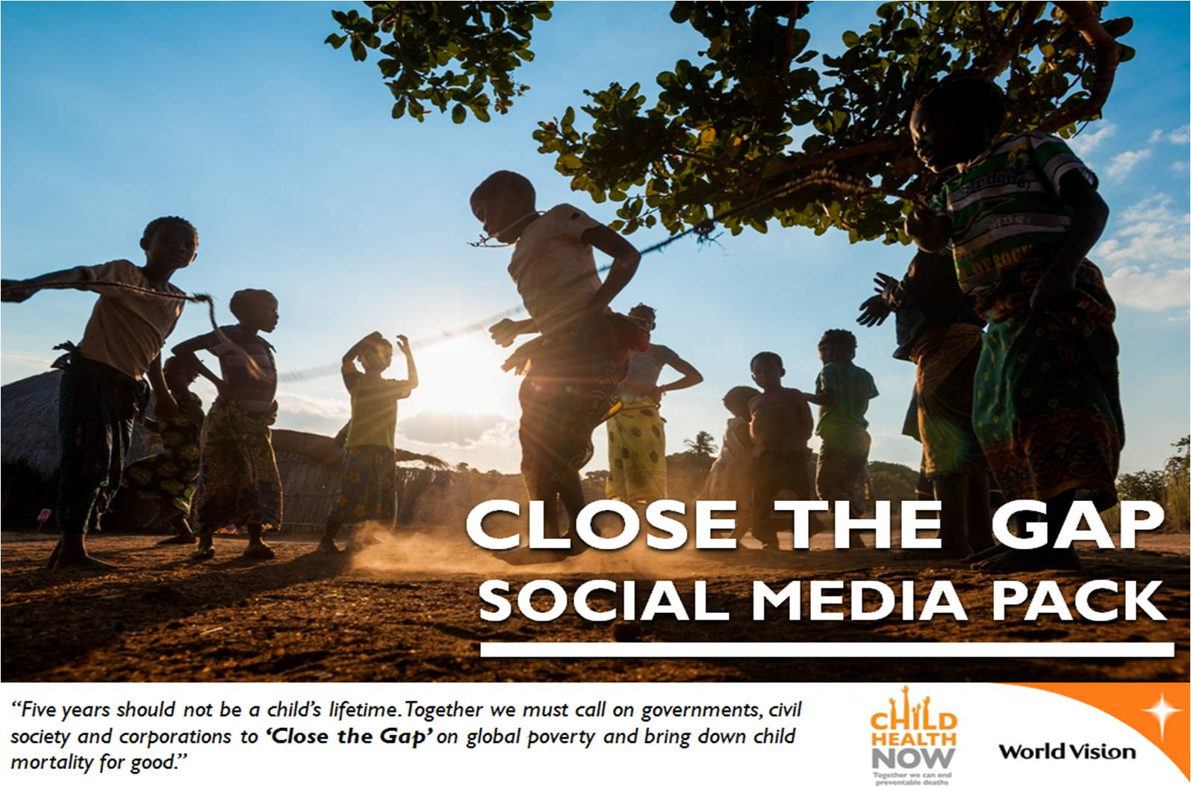

|  |
| --- |
|  |

**‘Close the Gap’ Social Media Pack**

‘Close the Gap’ in global poverty: together we can reach even the poorest and most vulnerable children, families and communities. We can #ClosetheGap by prioritising and investing in the most vulnerable, hardest to reach, and often overlooked places.

With two years left until the Millennium Development Goals (MDGs) 2015 deadline, much more needs to be done if the MDGs are to be met and millions of children can Survive 5. That's why the Child Health Now campaign will mobilise 4-10 September 2013, ahead of the 2013 United Nations General Assembly (UNGA), to call on world leaders to #ClosetheGap on poverty so that all children can Survive 5.

This pack contains everything you need to participate in #ClosetheGap activities through social media networks. Ranging from pre-written tweets, promoting the event, through to videos and Facebook graphics. You will find all you need to raise awareness through your own channels in your own way.

**You Can Be A #GapCloser**

**Key hashtags and handles**

* #ClosetheGap
* #GapCloser
* #WorldVision
* @Childhealthnow
* @WorldVision
* @WorldVisionUN

**Videos available**

* Pied Piper animation to child health – will be delivered with the ‘Stories and facts pack’ on 24th July
* ‘Join Hands so that All Children Can Survive 5’: <http://www.youtube.com/watch?v=AmUxwh7YlY0>
* ‘First 1000 Days’: <http://www.youtube.com/watch?v=J3IQOb3Aw0M>

|  |  |
| --- | --- |
| **Content to Promote the #ClosetheGap Mobilisation:** | |
| **Twitter** | On 4-10 September–call world leaders to [~~#~~ClosetheGap](https://twitter.com/search?q=%23ClosetheGap) on poverty so that all children can Survive 5 <http://bit.ly/15f9Q1R> |
| 4-10th September-it’s time to [~~#~~ClosetheGap](https://twitter.com/search?q=%23ClosetheGap). Show your support so all kids can Survive 5 <http://bit.ly/15f9Q1R> |
| 5.2million children will survive5 this year because of the progress towards the 2015 MDGs. Let’s finish the job: <http://bit.ly/15f9Q1R> |
| With 2 years left until MDG deadline, it’s time to call leaders to [~~#~~ClosetheGap](https://twitter.com/search?q=%23ClosetheGap) on poverty 2 tackle child mortality:<http://bit.ly/15f9Q1R> |
| **Facebook** | On 4-10 September we’re making a noise about child survival – let’s [~~#~~ClosetheGap](https://twitter.com/search?q=%23ClosetheGap) to help children survive 5 <http://bit.ly/15f9Q1R> |
| Since the MDGs were set in 2000, we’ve seen some great progress – this year 5.2 million children will survive 5 that would not have done thirteen years ago. But with 2 years left to the MDG 2015 deadline, there is still work to do. Help us make a noise on 4-10 September to call leaders to finish the job to meet the 2015 MDGs. We’re so close. It’s time to Close the Gap. <http://bit.ly/15f9Q1R> |
| Through a massive joint effort by governments, the UN, development organisations and others, we have now closed the gap to less than 7 million child deaths each year. But that is still 7 million too many. It is essential to Close the Gap on global poverty and leave no child behind. Show your support during 4-10 September. Help us Close the Gap. <http://bit.ly/15f9Q1R> |
| **Content to Promote the Campaign Action:** | |
| **Twitter** | You can be a [~~#~~GapCloser](https://twitter.com/search?q=%23GapCloser) 2 end preventable child deaths. Take our new campaign action to [~~#~~ClosetheGap](https://twitter.com/search?q=%23ClosetheGap): <http://bit.ly/15f9Q1R> |
| Take action and help finish the job to meet the 2015 MDGs! Let’s [~~#~~ClosetheGap](https://twitter.com/search?q=%23ClosetheGap): <http://bit.ly/15f9Q1R> |
| Every 24 hrs 19,000 children under 5 die due 2 preventable causes like diarrhoea. Join our campaign to take action: <http://bit.ly/15f9Q1R> |
| **Facebook** | Let’s end under 5 preventable child deaths. Take our new campaign action to [~~#~~ClosetheGap](https://twitter.com/search?q=%23ClosetheGap) on global poverty: <http://bit.ly/15f9Q1R> |
| The MDGs are the most successful anti-poverty push in history. Let's push 2 meet the 2015 deadline to end preventable child deaths: <http://bit.ly/15f9Q1R> [~~#~~ClosetheGap](https://twitter.com/search?q=%23ClosetheGap) |
| *You can be a ‘GapCloser’ to end preventable child deaths. Find out how you can help – take our new campaign action to Close the Gap on glob*al poverty to end preventable child deaths: <http://bit.ly/15f9Q1R> |

|  |  |
| --- | --- |
| **Other Health & MDG Related Content for Networks:** | |
| **Twitter** | Fragile&Conflict-affected states suffer the worst rates of [~~#~~malnutrition](https://twitter.com/search?q=%23malnutrition). Let's [~~#~~ClosetheGap](https://twitter.com/search?q=%23ClosetheGap) so all kids can Surive5 <http://bit.ly/15f9Q1R> |
|  |
| More than 100 million children under age 5 are still undernourished and underweight. Let’s #ClosetheGap to bring down child mortality. |
| Despite steady gains, 1 in 4 children show signs of stunted growth. Let’s finish the job to meet the 2015 MDG deadline. Let’s [~~#~~ClosetheGap](https://twitter.com/search?q=%23ClosetheGap) |
| Under 5 child deaths worldwide has dropped from nearly 12 million in 1990 to <7 million in 2011. Let’s finish the job. Let's [~~#~~ClosetheGap](https://twitter.com/search?q=%23ClosetheGap) |
| Global reduction in #malnutrition has stalled- undermined by global food, fuel and economic crises but also by #conflict and #unrest |
| 21st Century innovations:itunes, solar shingles& the electric car. What about ending preventable child deaths?[~~#~~Changeispossible](https://twitter.com/search?q=%23Changeispossible) [~~#~~ClosetheGap](https://twitter.com/search?q=%23ClosetheGap) |
| Immunisations help combat Pneumonia and Diarrhoea #GapClosers #ClosetheGap |
| Over the past 22 years the number of children dying before age 5 has dropped from 12 million to 7 million #Changeispossible #ClosetheGap |
| Over the past 22 years we've seen a 42% reduction in number of under 5 child deaths. Let’s finish the job to meet the 2015 MDGs [~~#~~ClosetheGap](https://twitter.com/search?q=%23ClosetheGap) |
| Governments must not lose sight of the ‘unfinished business’ of the MDGs. Let’s finish the job. [~~#~~ClosetheGap](https://twitter.com/search?q=%23ClosetheGap) |
| The [#MDGs](https://twitter.com/search?q=%23MDGs) have been equity-blind; the poorest and most marginalised children have been overlooked by health-efforts.Let’s #ClosetheGap |
|  | 21st century innovations:the hybrid car, Facebook & the iPod. What about ending preventable child deaths?#Changeispossible #Closethegap |
| **Facebook** | The UNGA is a critical moment in the process towards 2015 MDGs. Lets raise our voices to show leaders that we must not lose sight of the ‘unfinished business’ of the MDGs. |
| Did you know: The number of under-five child deaths worldwide has dropped from nearly 12 million in 1990 to less than 7 million in 2011 – a 42% reduction! So much has been done. But let’s finish the job. Let’s Close the Gap to end preventable child deaths. |
| *Water sanitation and hygiene helps tackle childhood infections. These are some of the ‘Gap Closers’ that are bridging the divide between th*e global rich and poor to end preventable child deaths. You can be one too <http://bit.ly/15f9Q1R> |
| *We’ve seen some amazing innovation in the 21st Century: iTunes, solar shingles & the electric car. But what about ending preventable child* deaths? You can help us Close the Gap on global poverty to help children Survive 5: <http://bit.ly/15f9Q1R> |