Scope of Work for Kombolcha Rub-hall Canvas replacement (Supply and Installation)
- The location of the work (installation of canvas roofing) is in the town of Kombolcha, 380 Km from Addis Ababa, Ethiopia.
- The work included both the supply and installation of canvas roofing for the commodity warehouse located at the above address per the specification outlined herein. The supply and installation is only for the ROOF CANVAS; where the wall is made of Galvanized Iron sheet (please see image #2). The installation should properly fit the existing structure and should not have any holes or opening which will compromise the safe keeping of the commodities inside the ware house.
- The supply and installation shall include the safe dismantling and removal of the existing Canvas without any damage to the structure of the warehouse.
- The Canvas shall have the following specification
- Type:- W. GIERTSEN NG3 (NV 3 Outer skinn 900g/m2)
- Width: 20 meter
- Ridge height: 9.5 meter
- Wall Height: 3 meter
- Length: 81 meter, with appropriate module: where the spacing of the wall and roof truss is 3 meters interval with a total of 28 set of trusses.
- Gate, max size: 2 Gates of 4 meter by 4 meter
- Air vent- 4 PVC air vent- 2 in each gable side.
- CANVAS:
• Double coated high strength PVC extra UV stabilized, with antifungal treatment and fire proof
- Base Fabric:- Polyester, 1100dtex
- Width: 204 cm
• Weight: 900gm/m2
• Color: - White or Beige as preference or other considerations can be made
- Weld quality-High Frequency

• TECHNICAL SPECIFICATIONS

CANVAS  DIN 53352 | Tensile strength warp/weft  DIN 53354 | Tear strength warp/weft  DIN 53356 | Adhesion  (EN ISO 2411 2000) | Flame retardancy  SIS 650082 /  DIN 4102B1 | Temperature resistance  DIN 53361
ca.900g/m2 | ca. 3800/3800N/5cm | ca.1000/1000N | 100N/ 5m | Satisfactory | -30/+70 °C

- Canvas shall extend to the Iron sheet wall up-to 20 cm of the wall and a total of 60 cm from the top vertical edge leg of the truss in all directions. (See drawing 1 and image # 1 next page for more detail )
- Quality System - As approved by ISO 2001:2008
- Certification-ISO 9001-2008 and Central approval for building class 211.
- Origin: No preference￼

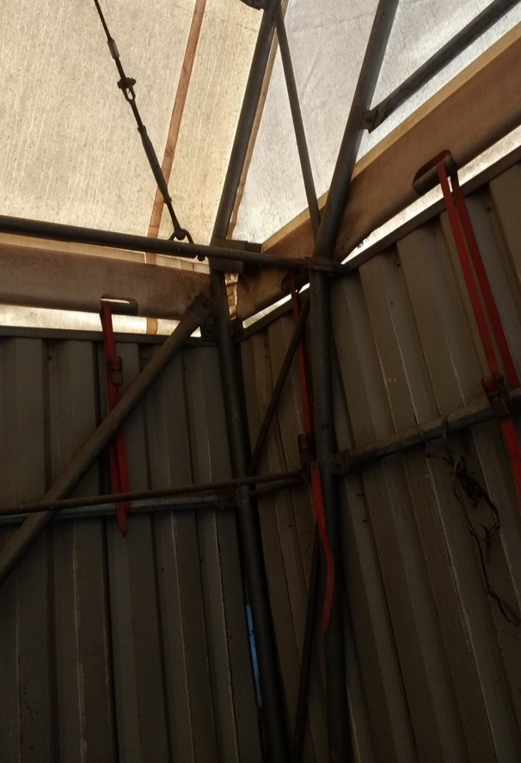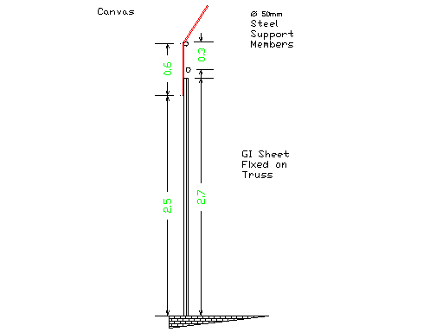
Photo 1 Drawing 1

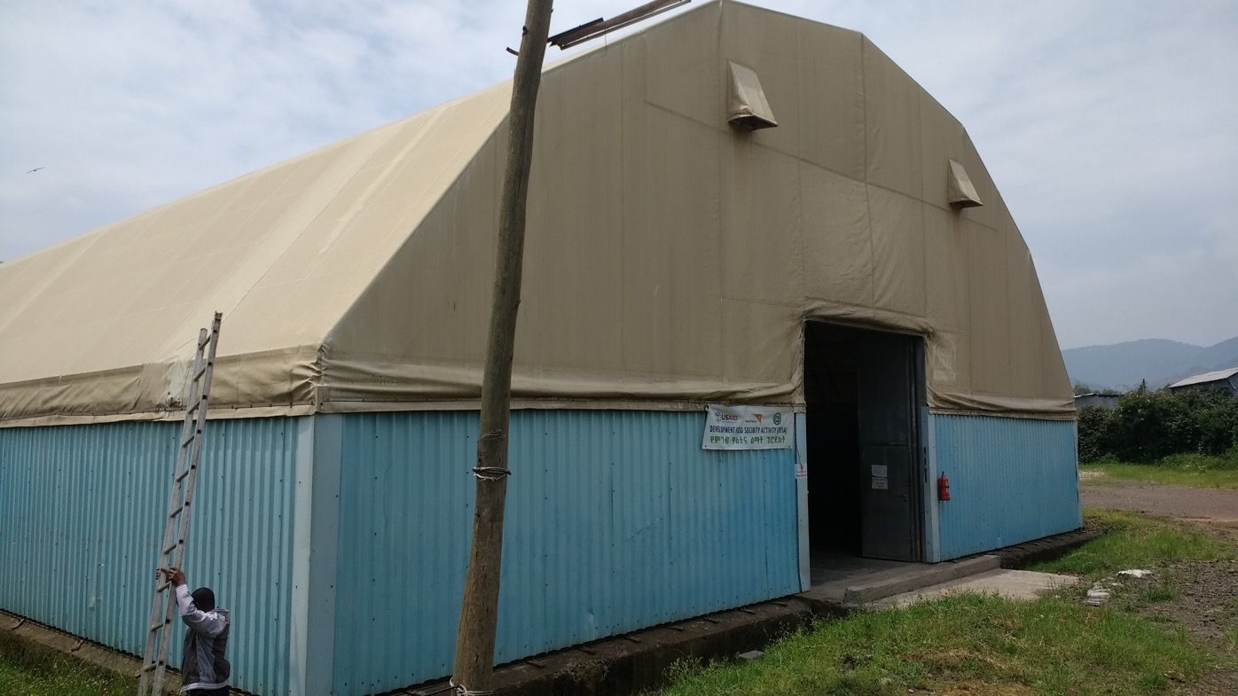
Photo2

