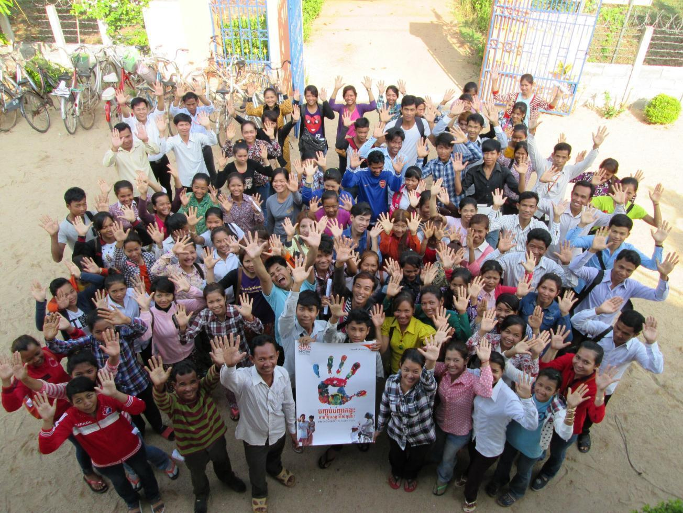

GLOBAL WEEK OF ACTION

partnerS resources pack – Health & Nutrition

2





welcome

Welcome to World Vision's Global Week of Action partners resource pack. In this pack you will find information about the upcoming mobilisation set to take place 4-11 May 2015, ways to partner with World Vision globally or at national level and ideas on the types of activities that you can engage in.

The Global Week of Action is World Vision's global campaign event that aims to unite our offices and our partners in joint action. Together, in 2014, we mobilised almost 6 million people to take action for improved child health and nutrition. Thank you for all you did to make this happen!

This year we will *Stop at Nothing* to make as much progress as possible towards the MDGs and reach an ambitious, world changing post-2015 agenda that will set the course for sustainable development for the next 15 years.

This includes ensuring that commitments made to the *Global Strategy for Women’s and Children’s Health* have been met and demonstrating how the *Every Woman Every Child* movement and accountability models that grew out of it have contributed to accelerated progress for women’s, children’s and adolescents’ health. As the updated *Global Strategy for Women’s, Children’s and Adolescents’ Health* is being developed we must ensure that it puts the rights and needs of the most vulnerable groups, such as newborns, adolescents and those living in fragile and conflict settings, as a priority and that there are clear mechanisms for accountability that allow citizens to participate in monitoring and review. World Vision invites its partners to align around the various consultations to develop the updated Global Strategy, at regional and national meetings, [online](http://www.womenchildrenpost2015.org) and through Citizens’ Hearings being planned by civil society organisations in a number of countries.

**HIGH STAKES**

This year the stakes are even higher with vital negotiations taking place on a set of sustainable development goals to replace the MDGs.

* We need millions of children's voices to be heard in the debates among world leaders.
* We want millions of citizens and community members to be represented in those rooms, in those discussions.
* We will demand that leaders take notice, and by coming together we can make this happen.

We will partner with action/2015 coalitions around the world and many other partners to generate widespread community-led mobilisation in May in order to increase the impact of our collective voices and demonstrate the unity of our action. The national and global support that we will mobilise together will demonstrate to leaders that the public want to see continued and increased action on improving child health, nutrition and well-being, reducing poverty and abuse. We will let leaders know that we will *Stop at Nothing* to see the dream of a safe, healthy childhood fulfilled for every child and that we expect them to do the same.

Throughout this brief partners pack you will find information and guidance on how to get involved as well as links to other useful resources. Feel free to use, repurpose and join. We know that social media is a key way for us to partner and we’ll share those targeted resources closer to the time.

Thank you in advance for partnering with us ahead of and during the Global Week of Action: Stop at Nothing. Together we are stronger!

With hope and excitement, **World Vision’s Global Campaigns Team**

MENU OF ACTIONS

There are various activities your organisation can get involved with in order to support the Global Week of Action from 4–11 May 2015. They’re quick to organise and easy to do! Use the information and templates linked to this pack to help mobilise your staff, supporters and communities. Choose the ideas that work best for you and your context, and feel free to adapt them for your audiences and communities.

We would recommend making public events the priority as you can involve many supporters and communities, so focus on external events first. Involving outside audiences will ensure that decision makers hear all our voices!

**TOP ACTIONS**

**Here are the top actions your organisation can take as part of the Global Week of Action.**

* **Partner with World Vision's plans -** as part of the GWA we are expecting activities in 70 countries, we will be sharing details of activities partners can join and support - join us!
* **Join partnership opportunities -** in 2015 there are many great partnership opportunities, GWA, GCAP's Global Moves for Justice, action/2015 events, consultations around the updated Global Strategy for Women’s, Children’s and Adolescents’ Health and National Citzens’ Hearings. Find out more about what these are and how to engage in these in the 'Further resources' section
* **Promote the make a zero action -** our symbolic action of the campaign show your support by making a zero with your hands (using one or both.) This zero represents our ambition to get to zero poverty and is perfect for individuals or groups. Once you take your photo upload it to our interactive photowall (see next page for more details).
* **Get active online -** social media resources, videos, interactive photowall will all be made available. Share, promote and help spread the word. We are keen to get our message out to as many people as possible and your support in doing this is vital. This pack will be shared on 1st April.

For all organisations partnering for the GWA we would love to share your logo and website link on our main Global Week of Action page, so please do send these to [Ben Grierson-Hill, Popular Mobilisation Manager.](mailto:ben_grierson-hill@wvi.org)

**The key action – *Stop at Nothing* ‘make a zero’ photos**

A photo action is one of the easiest ways for everyone to engage. In recognition of our ask for a world where zero children die from preventable causes, zero children are victims of violence or abuse and zero children go hungry, we are asking supporters, communities and the public to ‘make a zero’ with their hands to show their support.

This action is very simple, appealing and effective for individuals and groups to do – whether communities or staff or large groups. The photos will demonstrate to leaders that people care about saving children's lives and want them to take action to get to zero. It’s an easy action, so involve as many people as you can.

Here’s how it works:

1. Either on your own or with a group – (family, friends, work colleagues, sports buddies or church group) find a space to take a photo – either a selfie or a group shot. If it is a group you may want to read them the Global Week of Action pledge.
2. Using a smartphone or camera, take a picture of the group (or a selfie if on your own) where each person is making a clear ‘zero’ with their hands.
3. You could take the pose in different forms, making a zero with one hand, both hands or joining hands with someone else. Just make sure the ‘zero’ is clear!
4. Upload your photo(s) to the website [www.childhealthnow.org/gwa](http://www.childhealthnow.org/gwa), where you’ll join thousands of people around the globe campaigning for change.
5. Use #StopatNothing on social media to help you share your photos and events with the world! Inspire as many people as possible so this issue can’t be ignored.

At the end of the Global Week of Action we’ll use your action globally to urge leaders to honour their promises to improve maternal, newborn and child health and nutrition and to call for an ambitious post-2015 agreement.

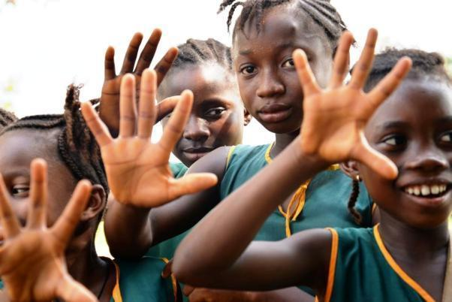

Children in Sierra Leone raising their hands for health. Credit: World Vision

**FURTHER RESOURCES**

**Action/2015:** The global coalition of development and climate change organisations who want to unite their voices and raise a powerful voice for progress and change. Look for opportunities to partner with your action/2015 national coalition. [Visit the website.](http://www.action2015.org/)

**Arrange or join a Citizens’ Hearing:** Through 2015 World Vision, Save the Children, the White Ribbon Alliance and others will be convening a series of national and sub-national hearings on maternal, newborn, child and adolescent health. These can mobilise the public and give communities a chance to speak to decision makers about issues that affect their lives. These hearings will also provide critical citizen input into the consultations on the updated Global Strategy for Women’s, Children’s and Adolescents’ Health. Consider partnering with hearings taking place in your country or use the materials here to host your own. [Download resources.](https://drive.google.com/open?id=0BxMOcpqR2Zjzb3RIYXZCNXVla2c&authuser=0)

**Event guide:** Throughout the Global Week of Action and other mobilisation activities in May there will be an exciting chance to bring people together from across the globe to influence leaders and decision makers. Through events we have the opportunity to gather and inspire the public and communities. Find here suggestions on the different type of events you could run and a step by step guide for planning a successful event. [Download resources.](https://drive.google.com/open?id=0BxMOcpqR2ZjzaDRrY3BuN3B6UVE&authuser=0)

**Faith resources:** Faith is a powerful mobiliser and an effective network for change – many communities are strongly motivated by a call to justice through their faiths. We will work with different faith networks during Global Week of Action, and as a Christian organisation, have provided some resources for churches. Through the action/2015 Faith Action Team we are helping create interfaith resources which will be available online. We have provided a sermon guide with verses and suggested talking points. [Download resources.](https://drive.google.com/open?id=0BxMOcpqR2ZjzVDMzQ2ZHU3NjSjQ&authuser=0)

**Partner engagement:** World Vision will be making available a list of core activities taking place in country that your organisation could partner with. We will be sharing a link to a google document where you can see what is happening in your country. As we get more information about planned activities and partnerships we will add this in.

**Social media:** As we get closer to the Global Week of Action we will be sharing more resources and information about engaging online. We will be **releasing this pack on 1st April** so keep an eye out for updates and in the meantime follow the #StopatNothing hashtag.

**Questions? Comments? Please email Ben Grierson-Hill** [**ben_grierson-hill@wvi.org**](mailto:ben_grierson-hill@wvi.org) **for any help or check out** [**www.wvi.org/childhealthnow**](http://www.wvi.org/childhealthnow) **Twitter @ChildHealthNow or find us on Facebook**

**Thank you for being a partner for change! together we can end preventable deaths.**