Technical Brief: Community Health SErvices Costing and Planning Pilot in Malawi and Sierra leone

Prepared for the HSR Symposium – Vancouver - November 2016

Background

Costing of Community Health Services
There is growing evidence on the benefits of community health services (CHS) as a key strategy to promote healthy behavior and improve access to high-impact maternal, newborn, and child health interventions from pregnancy to adolescence. Much less is known, however, of the financing needs for effective, comprehensive CHS and, without this information, programs are often under-funded and financially unsustainable.

Management Sciences for Health (MSH), through funding and technical contributions from the United Nations International Children's Emergency Fund (UNICEF), developed a methodology and tool to support countries in the planning and costing of effective CHS programs. MSH piloted this methodology and tool in Malawi and Sierra Leone with the understanding that the results could be beneficial in improving and expanding CHS in both countries as well as in countries seeking to develop or advance comprehensive community health strategies.

Country Contexts
Community health workers (CHWs) play an important role in extending access to integrated health services and addressing priority health areas including maternal, newborn and child health (MNCH); family planning and reproductive health; nutrition; and water, sanitation, and hygiene (WASH); among others areas.

In Malawi, Health Surveillance Assistants (HSAs) have served as the link between health centers and communities and have represented a key component of the Ministry of Health’s (MOH) Child Health Strategy (2014-2020). Initially trained to provide childhood immunizations, the role of HSAs has been expanded to include a range of promotional, preventive, and curative services ranging from ante-natal and post-natal visits, integrated community case management (iCCM), and TB screening, among others. Situated eight km from health facilities, HSAs are critical to reaching the 86.2 percent of the country’s population living in rural areas.

In Sierra Leone, following the Ebola virus disease (EVD) outbreak, the Ministry of Health and Sanitation (MOHS) revised its National CHW Policy to expand the package of CHS to all rural and urban communities. Set to be implemented in 2016, the revised policy will vastly increase the number of trained CHWs and introduce a number of new services including the intermittent preventive malaria therapy (IPTp) for pregnant women; male condom distribution and refills of oral contraceptives; malaria case management services for adults; nutrition services; and integrated disease surveillance reporting, among others. In addition, the new CHW policy places greater emphasis on CHW training and supervision and stipulates increased financial incentives for CHWs, Peer Supervisors, and program support personnel.
unite for children

Methodology

Development of Community Health Planning and Costing Methodology and Tool
The CHS Planning and Costing Methodology and Tool is designed to help program managers develop effective, sustainable, and comprehensive community health programs. Based on inputs provided by the user, the tool calculates key results on the costs and required financing for the introduction, maintenance, or scale-up of comprehensive CHS programs at the national or sub-national levels. MSH finalized the tool and methodology based on the pilots conducted in both countries and feedback received from UNICEF and in-country partners.

Text Box: The CHS Planning and Costing Tool calculates the costs and required financing for all fundamental elements of a community health program including start-up costs, service delivery, training, supervision, and management. The tool automatically produces the following key results to facilitate program planning and sustainability:
- Total program costs for baseline year and ten-year projections;
- Costs per capita, per CHW, per contact, per program, and per resource type;
- Incremental costs and financing (start-up and recurrent);
- Key drivers of costs and cost categories as a percent of total costs; and
- Ten-year projections of financing (and financial gaps) with sources of funding.

Data Collection
In February and March 2016, MSH conducted three-week visits in each country to pilot the methodology and tool and collect the required data for the analysis. Due to limited time and resources, MSH staff collected data from a representative sample of two districts in each country, visiting two health centers (on average) in each district.

The sample districts (Table 1) and health centers were selected by the MOH and UNICEF based on their accessibility, representation (i.e. CHWs providing a range of services within the CHS package with varying catchment population sizes and geography), and availability of staff to participate in interviews. In Malawi, data was collected in Ntcheu and Dedza districts where HSAs were supported and supervised by MOH personnel. In Sierra Leone, data was collected in Bombali and Kono districts where CHWs were supported and supervised by the MOHS and personnel from the international NGOs World Hope International and the International Rescue Committee, respectively.

Table 1. Overview of sampled districts
 | Malawi |  | Sierra Leone
District | Dedza | Ntcheu | Bombali | Kono
Population (% Targeted by CHS)
2015 | 735,411 (33%) | 558,942 (33%) | 506,838 (33%) | 533,104 (38%)
2025ª | 994,489 (33%) | 755,852 (33%) | 631,165 (100%) | 663,874 (100%)
Total CHWs
2015 | 439 HSAs | 308 HSAs | 650 CHWs | 743 CHWs
2025^{b} | 439 HSAs | 308 HSAs | 1,249 CHWs | 1,346 CHWs
ª estimated 2025 population
^{b} the number of CHWs in 2025 was estimated for the purpose of cost modelling

Cost Modelling and Analysis
MSH personnel entered and analyzed all data using the spreadsheet-based CHS Planning and Costing Tool. For the baseline year (2015), MSH used actual service and cost data obtained by the MOHs and implementing NGO partners in each district. For future years of program implementation (2016-2025), MSH calculated the projected costs based on the future scale-up scenarios and the expected coverage of CHS, as determined by the MOHs. For all years of the analysis, the coverage rates were determined by dividing the actual or projected number of services by the expected number of services.

Findings
The pilots conducted in Malawi and Sierra Leone provided an invaluable analysis of the cost of CHS implementation and the various bottlenecks impeding the delivery and/or quality of CHS, as described in the following section.

Malawi

At the request of the MOH, MSH conducted a cost analysis of the HSA program in Ntcheu and Dedza districts from 2015-2025. These districts were also selected, as they are among the RMNCH priority districts in Malawi. The 2015 costs reflect those of the actual program in each district while the 2016-2025 costs reflect the ongoing implementation of the program with no additional geographic scale-up or expansion of the number of CHWs.

Service Utilization
Based on the reported 2015 service utilization data, the majority of services provided were for family planning and iCCM – HSAs only provided 14 of the 43 services in Ntcheu district and 12 of the 43 services in Dedza district, as per the MOH national package of CHS. Based on the analysis, HSAs were relatively under-utilized with only nine percent and eight percent of HSA time being devoted for service provision and job responsibilities in Ntcheu and Dedza districts, respectively.

Based on modelled projections (2016-2025), if the full package of CHS (43 services) is provided and the utilization of each service increases by five percent per year (Figure 1), it is estimated that by 2025, the time spent by HSAs for service provision will increase significantly to 77 percent in Ntcheu district and 69 percent in Dedza district.

Figure 1. Dedza district – Total Number of Community Health Services by Program (2015-2015)

Program Costs
In 2015, the total costs of the programs were US $715,443 and US $962,298 in Ntcheu and Dedza, respectively. The categories of services with the highest costs were iCCM and reproductive health/family planning while the main programmatic cost-driver in the two districts was HSA salaries. The average cost per capita in 2015 for the two districts was US $3.88 in Ntcheu and US $3.97 in Dedza which were relatively low due to the under-utilization of services.

By 2025, due to increases in service utilization, the total program costs would amount to US $1,829,590 and US $2,380,193 in Ntcheu and Dedza, respectively. With the projected increases in utilization, the cost per capita would increase to US $7.16 in Ntcheu and US $7.25 in Dedza by 2025. The programs with the highest costs in 2025 would be reproductive health / family planning followed by immunizations and iCCM. By 2025, the majority of the costs would be for medicines, supplies, and commodities (Figure 2).

Figure 2. Dedza district – Total Recurrent CHS Program Costs by Category (2015-2025), US $

Financing
By linking the different financing sources to each of the cost elements, the tool can be used to estimate the required financing and financing gaps of the CHS program in future years. These results can be used to facilitate the efforts of program planners in creating investment cases and advocating for the necessary domestic and/or external financial resources (e.g. through the Global Fund to Fight AIDS, Tuberculosis, and Malaria and the Global Financing Facility). This analysis was not conducted in Malawi for the piloting due to a lack of detailed financing data at that time.

Bottlenecks to Service Delivery
There were a number of bottlenecks identified which are likely to impede the expansion and utilization of the full package of quality CHS among the targeted hard-to-reach populations. The initial utilization of CHS was relatively low, with some services not utilized at all, with the exceptions being for malaria and pneumonia treatments and BCG immunizations, which were reportedly higher than the expected need.

Many HSAs reported not having functioning bicycles to facilitate their travel to and within communities. In addition, it was reported that many HSAs, despite receiving an initial training, were not trained to provide the full package of CHS (e.g. HIV voluntary counselling and testing). These bottlenecks may have impacted and may continue to contribute to the under-utilization of HSA services in the two districts.

Sierra Leone

At the request of the MOHS, MSH conducted a cost analysis of the 2015 CHS program and modelled the introduction of the revised National CHW Strategy and the corresponding programmatic changes beginning in 2016 in Bombali and Kono districts. These programmatic changes included the introduction of additional trained and equipped CHWs, the expanded geographic coverage of CHWs (to cover 100 percent of the districts’ population), and the inclusion of additional health services as part of the new CHS package, as well as a substantial increase in financial incentives. The costs of CHW management, training, supervision, and equipment also increased considerably compared to the 2015 cost estimates.

Service Utilization
In 2015, CHWs were under-utilized – in Bombali district, CHWs spent an estimated five percent of their time (based on an estimated 20 working hours per week) providing nine of the 42 services included in the package of CHS while CHWs in Kono district spent an estimated eight percent of their time providing 10 of the 42 services. Among the two districts, there were significant variations in the package of CHS offered. In Bombali district (Figure 3), CHWs did not provide iCCM treatments and the majority of services provided were for MNCH (ANC and PNC promotional home visits) and iCCM referrals. In Kono district in 2015, the majority of services were for iCCM and MNCH.

For the purpose of modelling (2016-2025), the coverage rates increased by 20 percent per year for the majority of services in the package (with the exception of third ANC promotional visits as well as refills of male condom distribution and oral contraceptives which remained at three percent coverage). For all services with reported 100 percent coverage in 2015, no increase was calculated. By 2025, the majority of services provided would be for iCCM and adult malaria case management.

Figure 3. Bombali district - Total Number of CHS by Program (2015-2025)

Program Costs
In 2015, the total costs of the programs were US $659,263 and US $495,332 in Bombali and Kono, respectively. The categories of services with highest costs were iCCM and disease prevention and control planning while the main programmatic cost-driver in the two districts was program management. The average cost per capita in 2015 for the two districts was US $3.92 in Bombali and US $2.48 in Kono which were also relatively low due to the under-utilization of services.

By 2025, due to increases in service utilization, the total program costs would amount to US $2,405,948 and US $2,701,878 in Bombali and Kono, respectively. With the projected increases in service utilization, the cost per capita would increase to US $3.81 in Bombali and US $4.07 in Kono by 2025. The programs with the highest costs in 2025 would be iCCM followed by adult malaria case management. By 2025, the majority of the costs would be for medicines, supplies, and commodities (Figure 4).

Figure 4. Bombali district - Total Recurrent CHS Program Costs by Category (2015-2025), US $

Financing
By linking the different financing sources to each of the cost elements, the tool can be used to estimate the required financing and financing gaps of the CHS program in future years. These results can be used to facilitate the efforts of program planners in creating investment cases and advocating for the necessary domestic and/or external financial resources (e.g. through the Global Fund to Fight AIDS, Tuberculosis, and Malaria and the Global Financing Facility). An illustrative financing scenario is included in Figure 4.

Figure 5. Bombali district – Illustrative financing projections by source and gap (2016-2025), US $

Bottlenecks to Service Delivery
In 2015, more than 80 percent of CHWs nationally covered between 0-500 people and less than 10 percent of CHWs covered more than 1,000 people. It is expected that with the introduction of the revised CHW policy in 2016, CHW coverage will increase considerably – the ratio of hard-to-reach CHWs (i.e. those beyond three km from the health facility) will be one to 250 persons and the ratio of CHWs within three km of the health facility will be one to 1,000 persons.

In both districts, stock-outs at the community level were a significant challenge in 2015. In Bombali district, CHWs did not receive any medicines or commodities for curative services (e.g. iCCM treatments); it was reported that this was due to both the unavailability of medicines and commodities for CHWs and the no-touch policy directive from the MOHS to refer all suspected iCCM cases to the health facility, following the outbreak of the EVD epidemic. In Kono district, the IRC reported considerable levels of stock-outs among CHWs. Unless the issue of stock-outs is resolved, the success and impact of the proposed expansion of the National CHS program will likely be limited.

Discussion
Despite having well-established CHS programs, there is minimal information on the long-term costs and financing requirements in both Malawi and Sierra Leone which remain heavily reliant on external donor funding. The results of the MSH-led pilots in Malawi and Sierra Leone provide estimates on the costs and the required financing for CHS programs for the years 2015-2025 which can be used to inform future program planning and performance monitoring.

In both countries, the costs of expanding the utilization of CHS relate mainly to an increase in variable costs for medicines, supplies, and commodities which are based on the number of services provided by CHWs. However, these costs may not all be incremental, since they may be replacing the costs of services currently provided at health facilities. Therefore, the expansion of CHS may reduce the overall health system costs, allowing for a more cost-effective use of health facilities and personnel.

Moreover, as CHS are provided free-of-charge and in close proximity to the target populations, the economic costs faced by household should reduce including those for out-of-pocket payments, productivity losses due to illness, and productivity losses due to premature mortality. In general, high utilization of CHS combined with lower fixed costs (for management, supervision, trainings, and remuneration) result in a lower average recurrent cost per capita.

Conclusions
The purpose of the pilots were to develop a methodology and tool to support countries in the planning and costing of CHS programs and use the results to help improve and expand programs in both Malawi and Sierra Leone. While CHWs serve a critical role in extending access to integrated health services, in 2015 the utilization of CHS and the numbers of services offered in the sampled districts was low which resulted in a lower cost per capita. By 2025, with the modelled increase in the utilization of CHS, the total program costs and cost per capita in all districts would rise with the increase in variable costs for medicines, supplies, and commodities.

Investment Case Development
The results of these pilots serve to support partners across a range of countries in the development of comprehensive community health strategies and investment cases. An investment case for introducing or expanding community health services should have three components:
- Projections for services, resource needs, costing and financing;
- Bottleneck analysis; and
- Impact analysis using the Lives Saved Tool (LiST).

The projections for services, related resource needs (e.g. staffing), costs, and financing can produced using the CHS Planning and Costing Tool.

The bottleneck analysis should identify existing bottlenecks and their impact as well as costed solutions for removing them. The cost of resolving the bottlenecks can also be included in the tool and the utilization of services can be adjusted to reflect their removal.

The impact analysis, which estimates the additional lives saved as a result of the expansion of certain health interventions, is conducted using the LiST Tool and can be re-entered into the Community Health Planning and Costing Tool.

These three components in combination should provide a compelling investment case that can be used to advocate for the necessary resources for introducing or expanding CHS programs

ACKNOWLEDGEMENTS
Co-researchers (alphabetical): David Colllins, Sarah Davey, Colin Gilmartin, Zina Jarrah, William Newbrander, Jerome Pfaffmann, Kemi Tesfazghi, and Christopher Villatoro, and Sara Wilhelmsen.

Special thanks are due to personnel from UNICEF offices in both countries, the Malawi MOH, the Sierra Leone MOHS, World Hope International, and the International Rescue Committee.

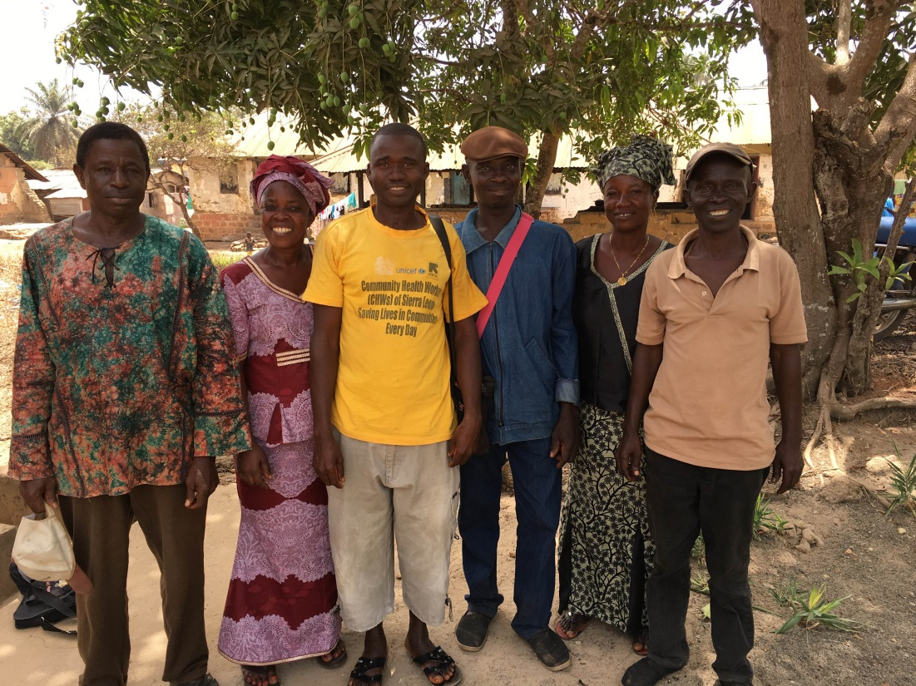

For more information on the CHS Planning and Costing Tool and country pilots: please visit www.msh.org and www.unicef.org.

Contact details: David Collins (dcollins@msh.org) and Jerome Pfaffmann (jpfaffmann@unicef.org)

Expressed as the anticipated number of episodes or cases per target population per year. For promotional and preventive services, the expected utilization rates should be based on national norms and standards. Certain preventive services, (e.g. family planning) are unlikely to have standard expected utilization rates and are based on current use and/or unmet need. For curative services (e.g. diarrhea treatment), expected utilization rates should reflect the expected number of cases in the target population per year.
UNICEF. 2015-16 Georeferenced Census of CHWs in Sierra Leone. 2016

